# CI-PLATFORM

### A PROJECT REPORT

***Submitted by***

**DEV PATEL**

191310132086

***In partial fulfillment for the award of the degree of***

## BACHELOR OF ENGINEERING

***in***

### INFORMATION & COMMUNICATIONS TECHNOLOGY

**ADANI INSTITUTE OF INFRASTRUCTURE ENGINEERING, AHMEDABAD**



## **ADANI INSTITUTE OF INFRASTRUCTURE ENGINEERING** ,**AHMEDABAD**

### April,2023

 

**ADANI INSTITUTE OF INFRASTRUCTURE ENGINEERING, AHMEDABAD, GUJARAT**

# CERTIFICATE

This is to certify that the project report submitted along with the project entitled **CI-Platform has** been carried out by **Dev Patel (191310132086)** under my guidance in partial fulfillment for the degree of Bachelor of EngineeringinInformation & Communication Technology, 8th Semester of Gujarat Technological University, Ahmadabad during the academic year2022-23.

|  |  |
| --- | --- |
| **Prof.PatelMahendraN.** | **Prof.J.S.Dhobi** |
| Assistant Professor | Head of the Department |
| Information & Communication Technology | Information & Communication Technology |

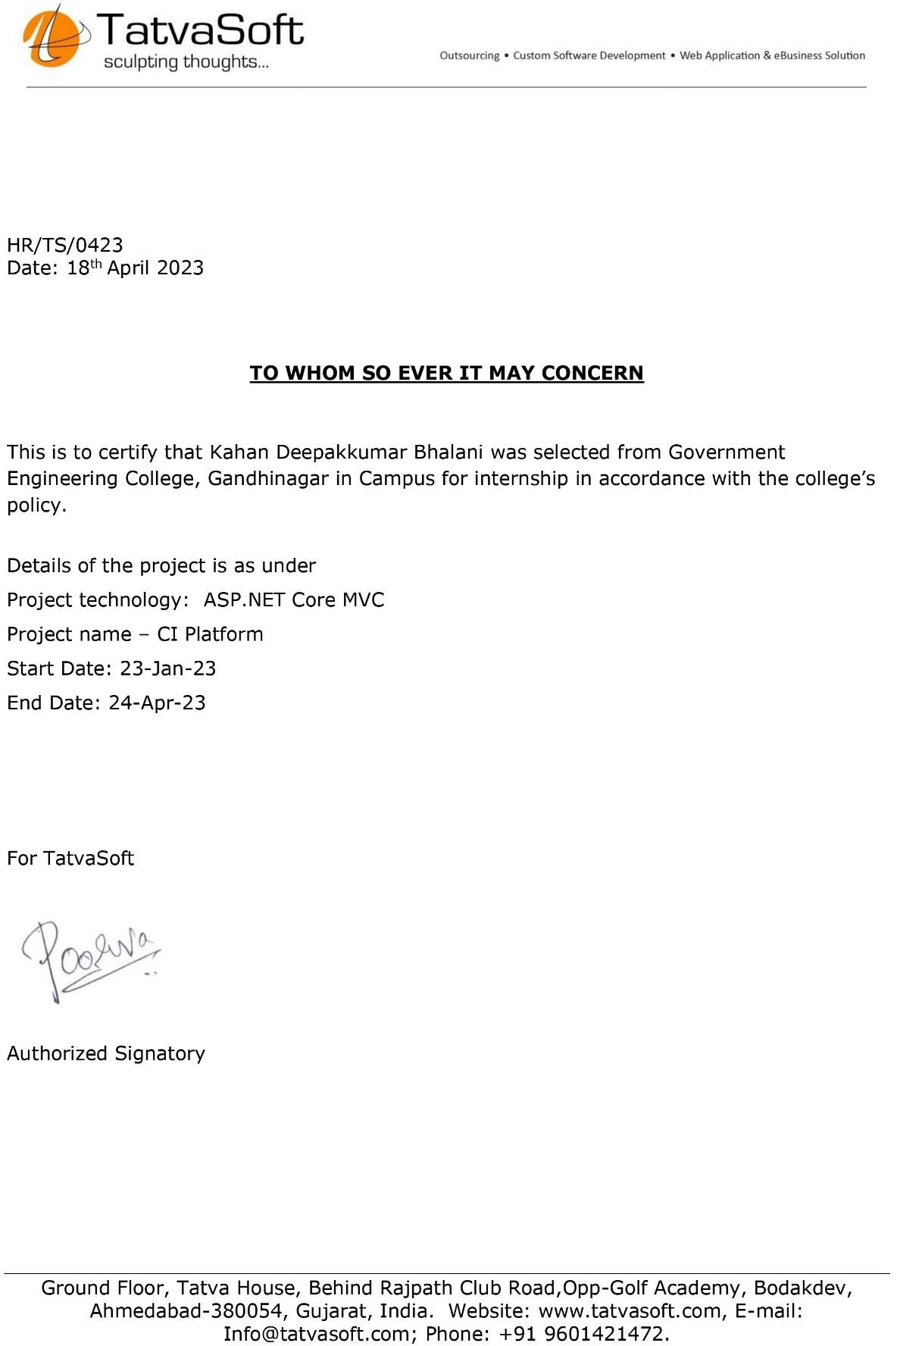

 

**ADANI INSTITUTE OF INFRASTRUCTURE ENGINEERING, AHMEDABAD, GUJARAT**

# DECLARATION

WeherebydeclarethattheInternship/ProjectreportsubmittedalongwiththeInternship/Projectentitled“**CIPlatform”submitted**inpartialfulfillmentforthedegreeofBachelorofEngineeringin**InformationTechnologyto**GujaratTechnologicalUniversity,Ahmedabad,isabonafiderecordoforiginalprojectworkcarriedoutbyme/usat**TatvaSoftunder**thesupervisionof**Mr. Patel Mahendra N.and that no part of this report has been directly** copied from any students’ reports or taken from any other source, with out providing due reference.

Name of the Student Sign of Student

1. Dev Patel

## ACKNOWLEDGEMENT

We would like to extend our heartily thanks with a deep sense of gratitude and respect toall those who has provided us immense help and guidance during our project. Especially,we would like to thank our mentor**Sweety Patel**who guided and introduced us to thecompanyand providednecessary resourcesandtheir encouragement.

We would like to express our sincere thanks to our internal guide**Prof. Patel Mahendrato providing a vision about the system and for giving us an opportunity to undertake such**agreatchallengingandinnovativework.Wearegratefulfortheguidance,encouragement,understandingand insightfulsupportgivenin thedevelopmentprocess.

We would like to extend my gratitude to**Prof. J. S. Dhobi**, Head of the InformationTechnologyDepartment.

Lastbutnottheleastwewouldliketomentionherethatwearegreatlyindebtedtoeveryonewhohasbeenassociatedwithourprojectatanystagebutwhosenamedoesnotfindaplaceinthis acknowledgement.

Yours sincerely,

Dev Patel(191310132086)

## ABSTRACT

# CI-Platform

*The aim and motivation of this industrial training is to receive discipline,skills,teamwork,andtechnicalknowledgethroughapropertrainingenvironment, which will help us, as a student in the field of InformationTechnology, to develop a responsiveness of the self-disciplinary nature ofproblems.*

*During this period of 12 weeks of training at TatvaSoft, we were assigned todevelopawebsiteforCI(CommunityInvestment)platformusingtheASP.NETCoreMVCframeworkandusingMicrosoftSQLServerfordatabase.Wewereacquainted with the latest tools from Microsoft to design and build websites.Welearntaboutarchitectingaprojectusinglayeredarchitectureandalsohadan opportunity to implement what we’ve learnt in the past as IT students todevelopanindustryproject.*

*Theplatformwillallowthecompanyto“planandmanageeffortthatseekstomotivate and enable employees to effectively serve community needs throughtheleadership oftheemployer.”*

## LISTOFFIGURES

Fig. 3.1Login Page 4

Fig.3.2Forgot Password Page 5

Fig.3.3Reset Password Page 6

Fig.3.4RegistrationPage 7

Fig.4.1MissionLandingPage 8

Fig.4.2Search Bar 9

Fig.4.3MissionSearchResults 9

Fig.4.4Filtered Missions 10

Fig.4.5NoMissions Found 10

Fig.5.1BasicMissionDetails 11

Fig.5.2MissionDescription 12

Fig.5.3Organization Details 13

Fig. 5.4Comments 13

Fig.5.5RecentVolunteers 14

Fig.5.6Related Missions 14

Fig.5.7VolunteeringMissionPage 15

Fig.6.1Story ListingPage 16

Fig.6.2Add/ Edit aStory 17

Fig.6.3Story Details Page 18

Fig.7.1Time& GoalTimesheets 19

Fig.7.2Add/ EditTimeEntry 20

Fig.7.3Add/ Edit Goal Entry 21

Fig.8.1MyProfile 22

Fig.8.2ChangePassword 23

Fig.8.3User Skills 24

Fig.8.4Contact Us 25

Fig.9.1Users List 26

Fig.9.2Add/ EditUsers 27

Fig.9.3CMSPagesList 27

Fig.9.4Add/ Edit CMS Page 28

Fig.9.5Missions List 28

Fig.9.6Add/ Edit Mission 29

Fig.9.7 Skills List 30

Fig.9.8Add/ Edit Skills 30

Fig.9.9ThemesList 31

Fig.9.10Add/ EditTheme 31

Fig.9.11MissionApplications 32

Fig.9.12Published Stories 33

Fig.9.13 BannersList 34

Fig.9.14Add/ Edit Banner 35

Fig.10.1UseCaseDiagram 36

Fig.10.2Class Diagram 37

Fig.10.3SequenceDiagram 38

Fig.10.4E-R Diagram 39

ACKNOWLEDGEMENT i

ABSTRACT ii

LISTOFFIGURES iii

LISTOFDIAGRAMS v

TABLEOFCONTENTS vi

CHAPTER1.OVERVIEWOFTHECOMPANY 1

CHAPTER2.INTRODUCTIONTO CIPLATFORM 3

CHAPTER3.AUTHENTICATION 4

* 1. LOGIN 4
  2. FORGOTPASSWORD 5
  3. RESETPASSWORDPAGE 6
  4. REGISTRATION 7

CHAPTER4.PLATFORMLANDINGPAGE 8

* 1. MISSIONLISTING 8
  2. SEARCHMISSIONS 9
  3. FILTERMISSIONS 10

CHAPTER5.VOLUNTEERING MISSION 11

* 1. MISSIONDETAILS 11
  2. MISSIONDESCRIPTION 12
  3. ORGANIZATION DETAILS 13
  4. COMMENTS 13
  5. RECENTVOLUNTEERS 14
  6. RELATEDMISSIONS 14

CHAPTER6. STORIES 16

* 1. STORYLISTING 16
  2. ADD/ EDITSTORY 17
  3. STORYDETAILS 18

CHAPTER7.VOLUNTEERINGTIMESHEET 19

* 1. TIMEAND GOALTIMESHEETS 19
  2. TIMEENTRY 20
  3. GOALENTRY 21

CHAPTER8. USERPROFILE 22

* 1. CHANGEPASSWORD 23
  2. USERSKILLS 24
  3. CONTACTUS 25

CHAPTER9.ADMINPANEL 26

* 1. USERS 26
  2. CMSPAGE 27
  3. MISSIONS 28
  4. MISSIONSKILLS 30
  5. MISSIONTHEMES 31
  6. MISSIONAPPLICATIONS 32
  7. STORIES 33
  8. BANNERMANAGEMENT 34

CHAPTER10. DIAGRAMS 36

* 1. USECASEDIAGRAM 36
  2. CLASSDIAGRAM 37
  3. SEQUENCEDIAGRAM 38
  4. E-RDIAGRAM 39
  5. DATADICTIONARY 40
     1. Banner 40
     2. City 40
     3. Comment 40
     4. Country 40
     5. CMS Page 40
     6. FavoriteMission 41
     7. Goal Mission 41
     8. Mission 41
     9. MissionApplication 41
     10. MissionDocuments 42
     11. MissionInvite 42
     12. Mission Media 42
     13. Mission Rating 42
     14. Mission Skill 42
     15. Mission Theme 43
     16. PasswordReset 43
     17. Skill 43
     18. Story 43
     19. StoryInvite 44
     20. StoryMedia 44
     21. Timesheet 44
     22. User 44
     23. UserSkill 45

CHAPTER11. CONCLUSION 46

REFERENCES 47

## CHAPTER1.OVERVIEWOFTHECOMPANY



**Address**:TatvaSoftHouse,RajpathClubRoad,Ahmedabad, Gujarat

**Tel.:+**919601421472

TatvaSoft is a Consummate Custom Software Development company delivering splendidbusinessITSolutionsandrelatedservicestocustomersacrosstheglobe.Ourdevelopmentservices are led by our dedicated and passionate team to provide best industry practicescombined with technology expertise and business domain knowledge to drive digitaltransformation. Our proficiency in understanding business challenges and professionalcompetenceallows us to createabetterexperienceforour customers.

TatvaSoft has emerged and marked our presence in different continents by providing Bespokesoftwaredevelopment servicesto all major Industry Domains.

TatvaSofthassuccessfullyservedformorethan1800successstoriesrangingfromEnterpriseleveltoStart-ups,whohavegrown alongsidethesuccessofthecompany.

At present TatvaSoft is a Robust Team having diverse skills with more than 18+ years ofTechnology experience engaging with customers at Deeper level to provide cutting edgesolutionsand innovations.

To convert your vision into reality, TatvaSoft assist you from software product ideation todesign, development, release, and maintenance. Every successful product is unique in itsmarketandwithitsuniqueness,itbringsriskanduncertaintiesduringthesoftwareproductdevelopmentprocess.

TatvaSoftasaleadingsoftwareproductdevelopmentcompanyconceptualizeandstrategizethe entire roadmap to reduce the risk, keep time and development cost under control andprovidehigh-qualitystable product.With highlycollaborativeapproach,

TatvaSoft understand the scope, business scenarios and potential user types to create aproduct with UX, cloud, data and security as their prime focus at present TatvaSoft is aRobust Team having diverse skills with more than 18+ years of Technology experienceengagingwithcustomersatDeeperleveltoprovidecuttingedgesolutionsandinnovations.

#### Company’sDifferentDepartments

* Prototyping&MVPDevelopment
* ProductArchitectureDesignService
* UI/UXDesignServices
* Maintenance&Support Services
* ProductDevelopment
* ProductTesting

## CHAPTER2.INTRODUCTIONTOCIPLATFORM

CI (**Community Investment**) platform can also be called employee volunteer program,workplacevolunteerprograms,corporatevolunteerprograms,companyvolunteerprograms, and other iterations. These programs are typically built to support a company’slarger corporate social responsibility program (CSR) or community engagement programor community investment program. Companies may have specific reasoning for buildingsuchplatformslikebuildingapositivebrandreputationorincreasingemployeeengagementin thecommunity.

We provide the users (volunteers) an easy to use interface for finding various types ofmissions created by various communities or organizations. The volunteers can participatein these events or missions to be a part of the community which also results in companygrowth.

Thevolunteerscanchoosetheirtypeofmission,eitherGoal-basedorTime-basedtoallowflexibilitywith working hours.

* Goal-basedmissionsdonothaveadesignateddeadlinetomeetandhaveatargettoachieve.
* Time-basedmissionshaveadeadlinetomeetandthevolunteermustreporthisdailyworkin terms ofhours.

ThecompanyisprovidedanAdminPortalaswellwhereallCRUDoperationsareallowedon different missions and admin can approve or decline a volunteer’s mission application.The volunteers can also share their experience regarding the mission by publishing a storywhichcanbeviewedbyothervolunteersto gathersomeinsightbeforeapplying toone.

## CHAPTER3.AUTHENTICATION

### LOGIN

Userscanlogintotheplatformusingtheiremailandpassword.Allauthenticationpageswillalsodisplaysomebannerimagestoshowtheplatform’spastachievementsandevents.

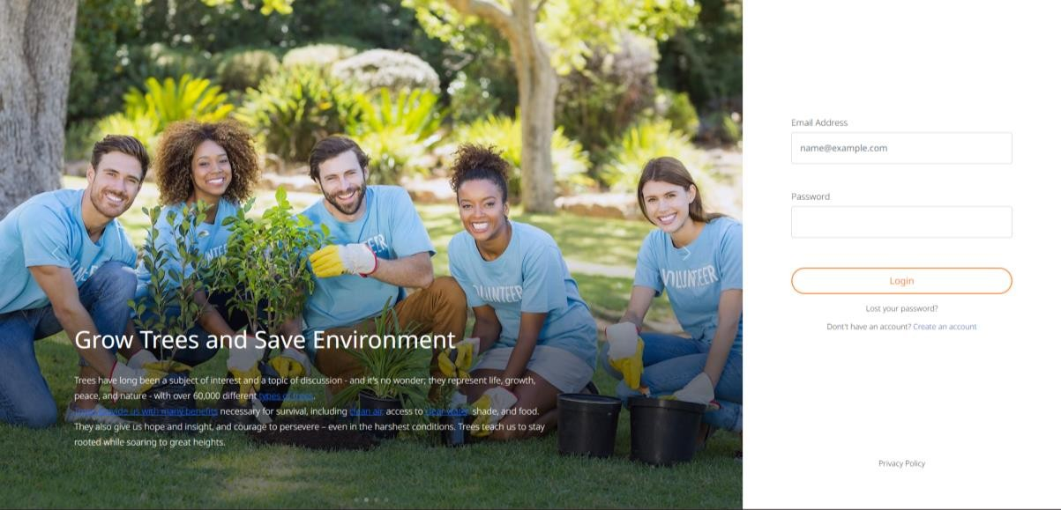

Fig.3.1LoginPage

Iftheuserhasforgottenthepassword,hecanclickon**Lostyour password?link**toresetthepassword by sendingareset passwordlink to hisemail.

Newusers cancreateanewaccountbyclicking**Createanaccountlink.**

### FORGOTPASSWORD

Users who have forgotten their password may request to reset their password by enteringtheir email address. System will check their email address existence, if it exists then resetpasswordlink will besentto theiremail address.

Thislinkautomaticallyexpiresafter4hoursorwhenitwasalreadyusedtoresetpasswordsuccessfully.

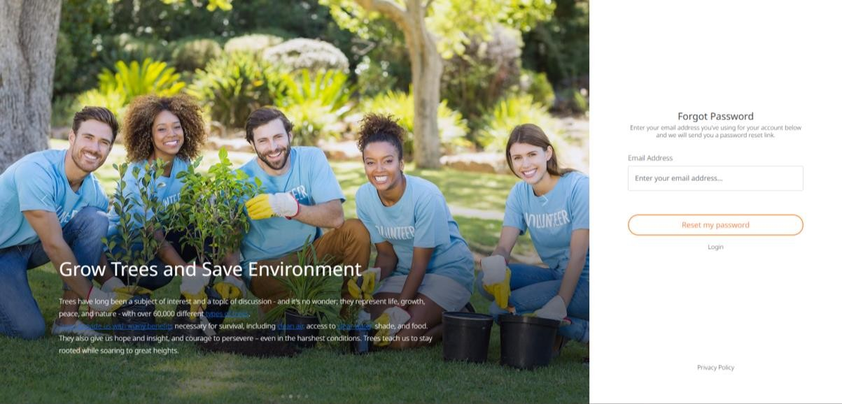

Fig.3.2ForgotPasswordPage

### RESETPASSWORDPAGE

Whenclickingonresetpasswordlinkfromemail,userwilllandtothispage.Hereusercanresethis password byentering newpassword.

Oncethelinkisexpiredafter4hours,thispagewillnotbeaccessible.

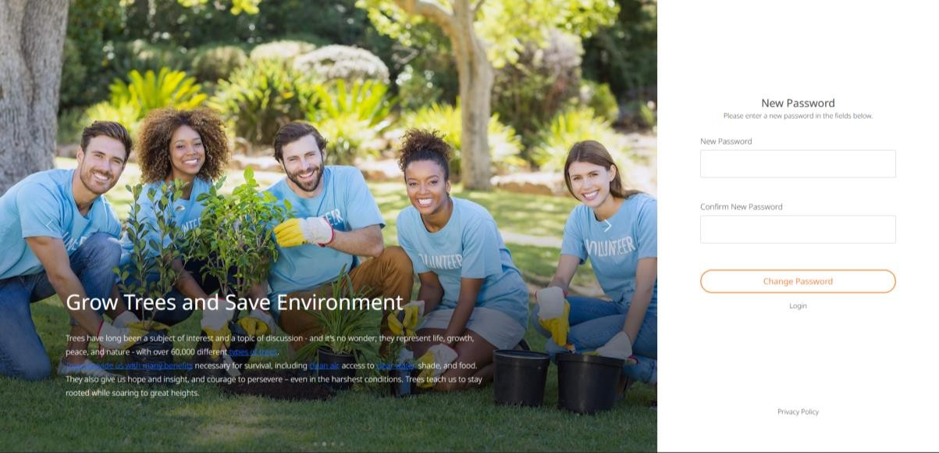

Fig.3.3Reset PasswordPage

### REGISTRATION

Newuserscanregisterasvolunteersbyproviding thenecessarydetailslikeemailaddressandphonenumber.

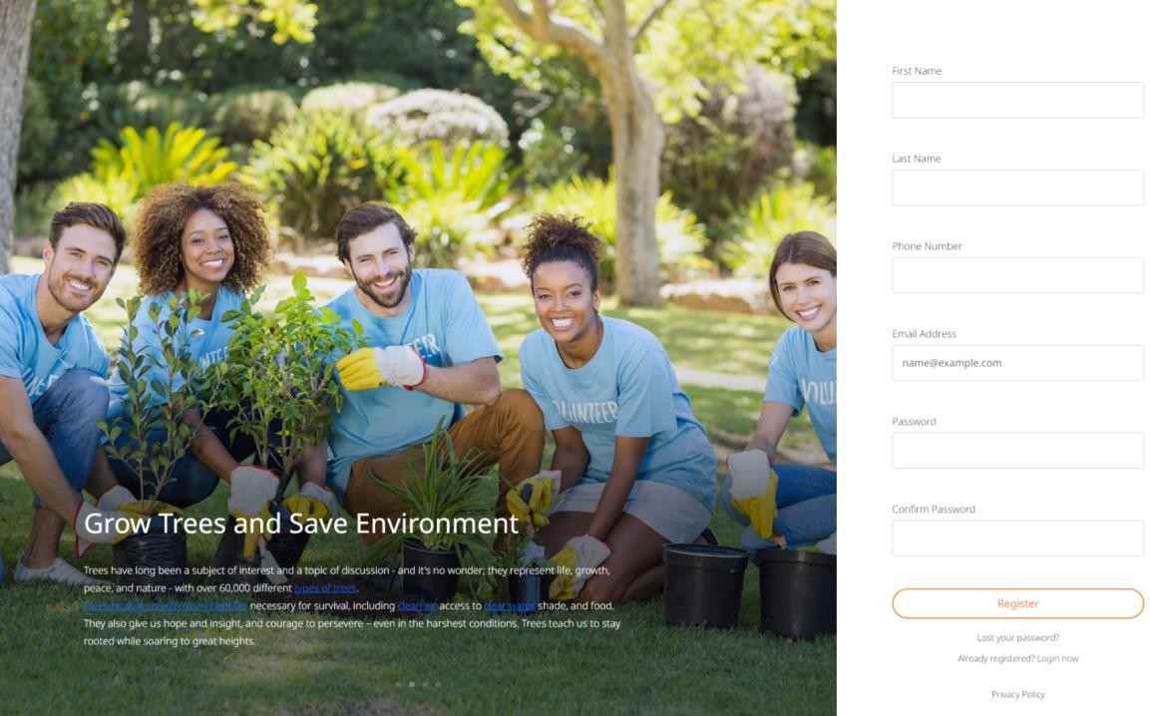

Fig.3.4RegistrationPage

## CHAPTER4.PLATFORMLANDINGPAGE

### MISSIONLISTING

After successful login, user will be redirected to platform landing page. This page willdisplayvariousmissions.Usercanfiltermissionsbythemeandskills.Usercanalsosearchmissionsbymissiontitle,missiondescription.UsercanviewmissionseitherbyGridVieworListView.

Therearetwotypes ofmissionsavailable inthisplatform:

* + 1. Time-basedMissions
    2. Goal-basedMissions

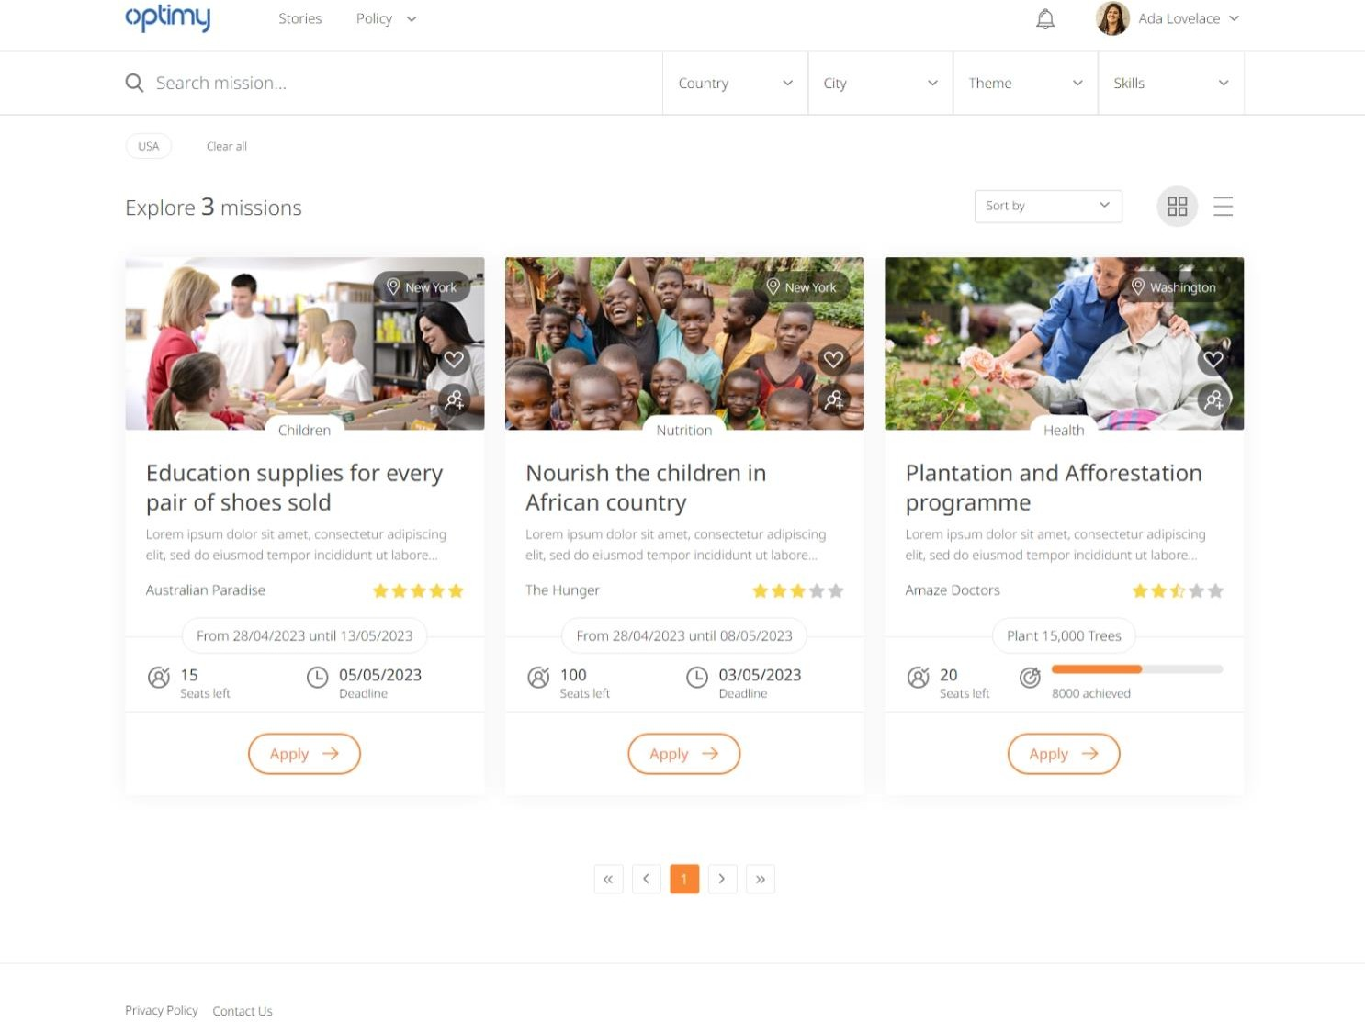

Fig.4.1MissionsLandingPage

### SEARCHMISSIONS

User will be able to quickly search by country then city then by theme then by skills. Usercanalso search missions by specifickeywords.



Fig.4.2.1SearchBar

Bydefault,itwillshowmissionsbelongingtotheuser’scityandcountry.Forsearching,thecountry filteris mandatory.

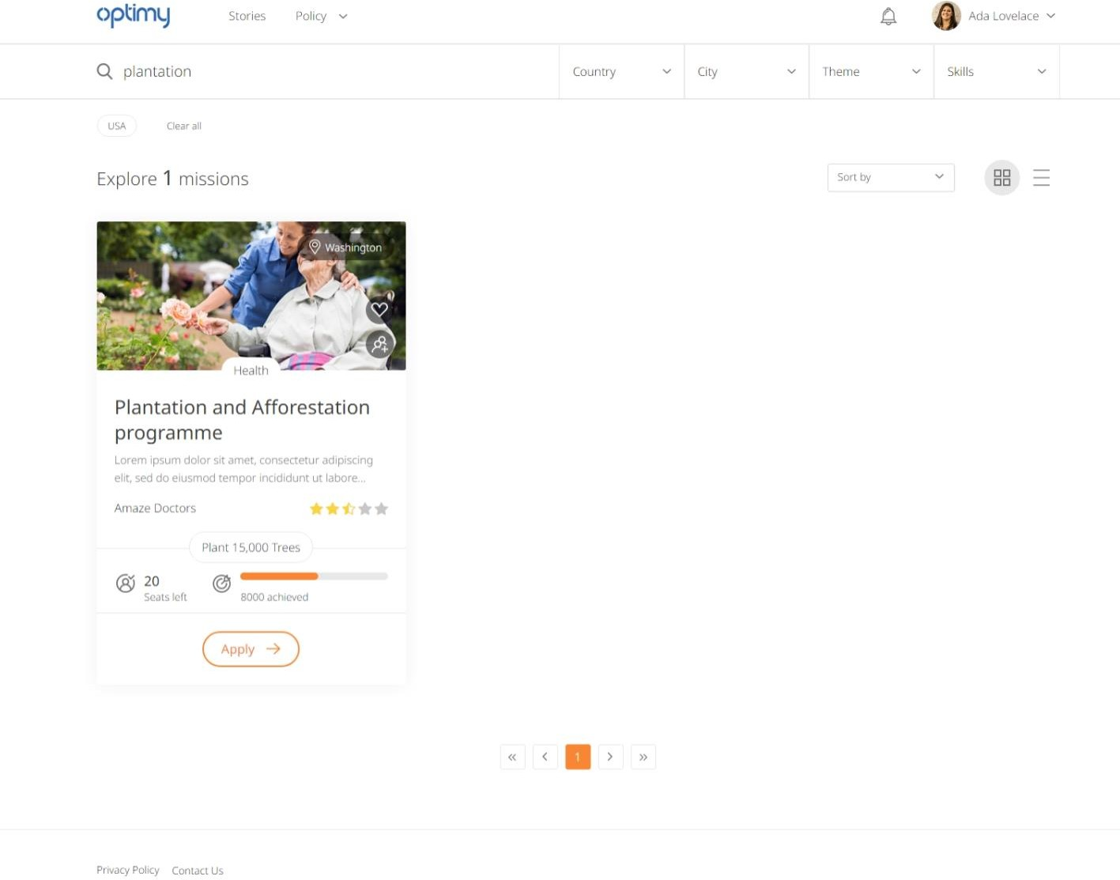

Fig.4.2.2MissionSearchResults

### FILTERMISSIONS

Wecanalsoapplyvariousfiltersbasedoncity,country,themeandskills.Theappliedfiltersarevisible below thesearch bar andcanbemodified by removingthem.

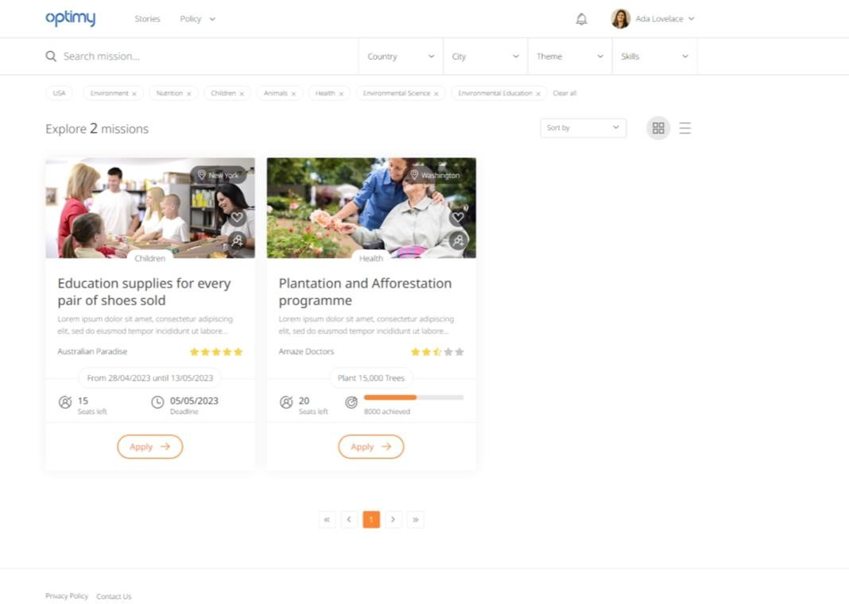

Fig.4.3.1FilteredMissions

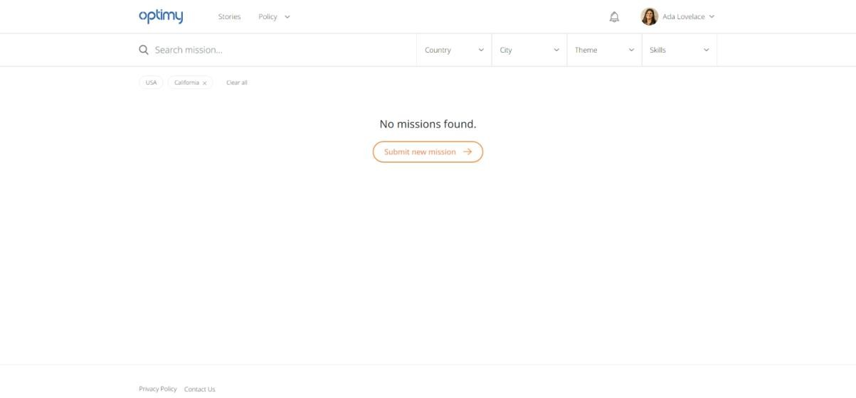

Fig.4.3.2NoMissionsFound

## CHAPTER5.VOLUNTEERINGMISSION

### MISSIONDETAILS

The Volunteering Mission page will display detailed information about a mission beforethe volunteer can apply for it. It displays some media in form of images and YouTubevideos.It also displaysavailable seats and theregistration deadline.

The user can give a rating to give their experience regarding the mission which will helpfuturevolunteersforthatmission.

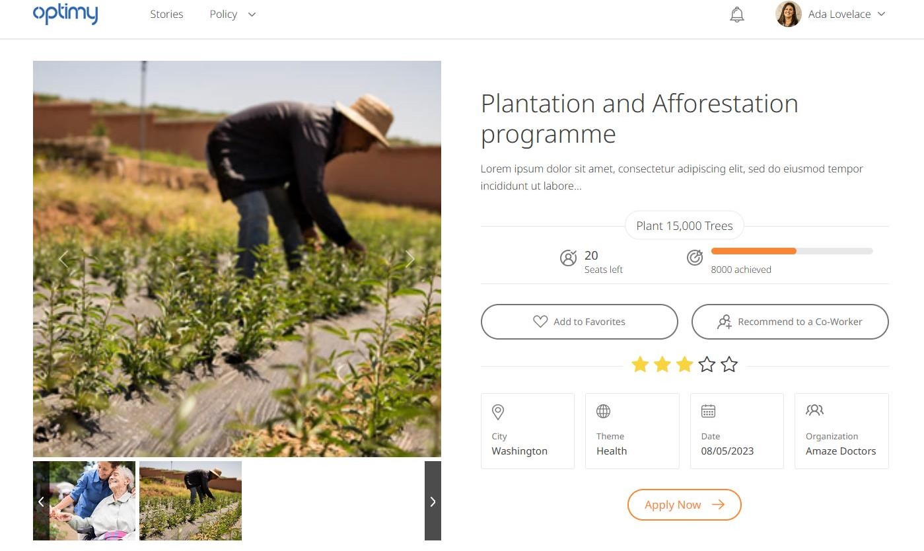

Fig.5.1BasicMissionDetails

### MISSIONDESCRIPTION

Thistabprovidesdetaileddescriptionaboutthemissionandwhyweshouldapplyforit.ItalsoprovideslinkstovariousdocumentsregardingthemissionlikePDFfilesandSheets.

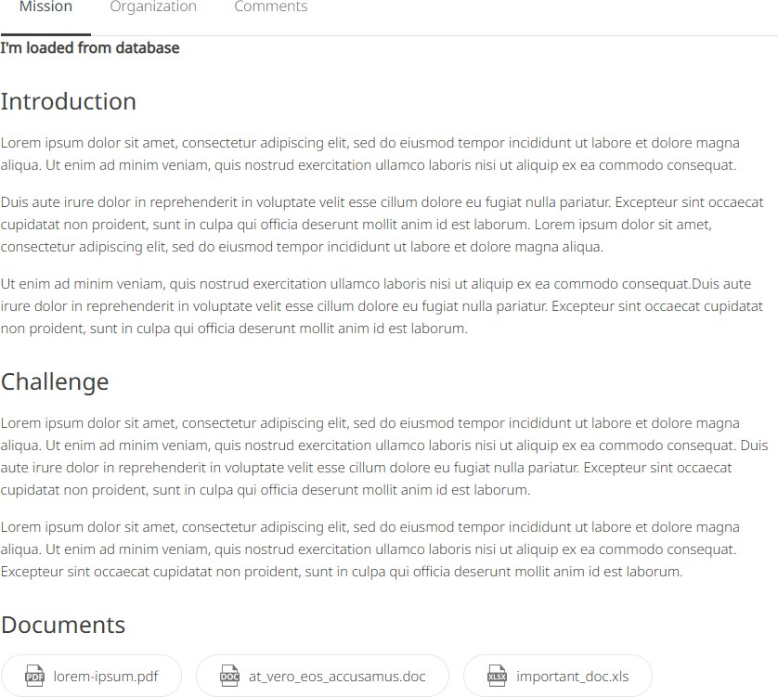

Fig.5.2MissionDescription

### ORGANIZATIONDETAILS

Thistabprovidesdetaileddescriptionabout theorganizationwhichcreated thismission.

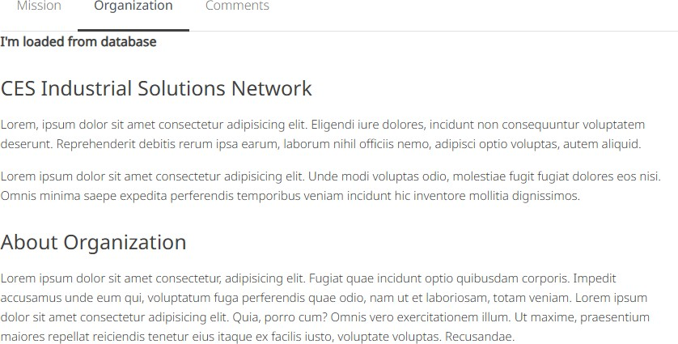

Fig.5.3OrganizationDetails

### COMMENTS

Userscangivetheircommentsregardingthemissiontoprovidefeedbacktotheorganizationandalsoallow futurevolunteersto reviewthemission.

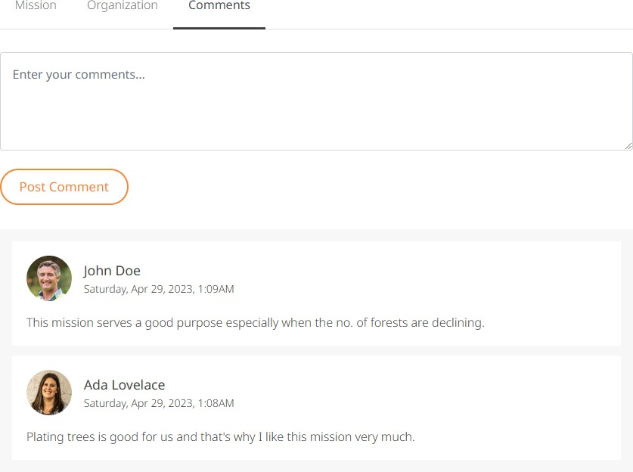

Fig.5.4Comments

### RECENTVOLUNTEERS

Onecanalsoseewhohadpreviouslyappliedforthismissionwiththeirnameandprofilepicture.

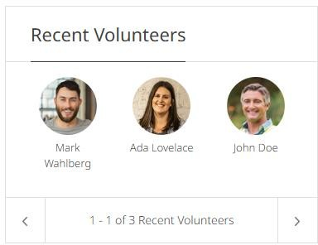

Fig.5.5RecentVolunteers

### RELATEDMISSIONS

Atthebottomofpage,wecanseemissionsrelatedtothecurrentmissionbycityandcountryi.e.missionsbelongingtothesame cityorcountry,orthesame theme.

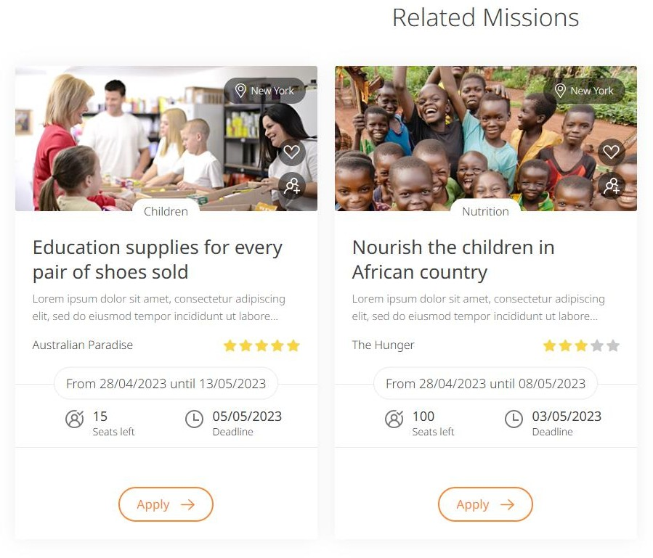

Fig. 5.6RelatedMissions

#### CompleteVolunteeringPage

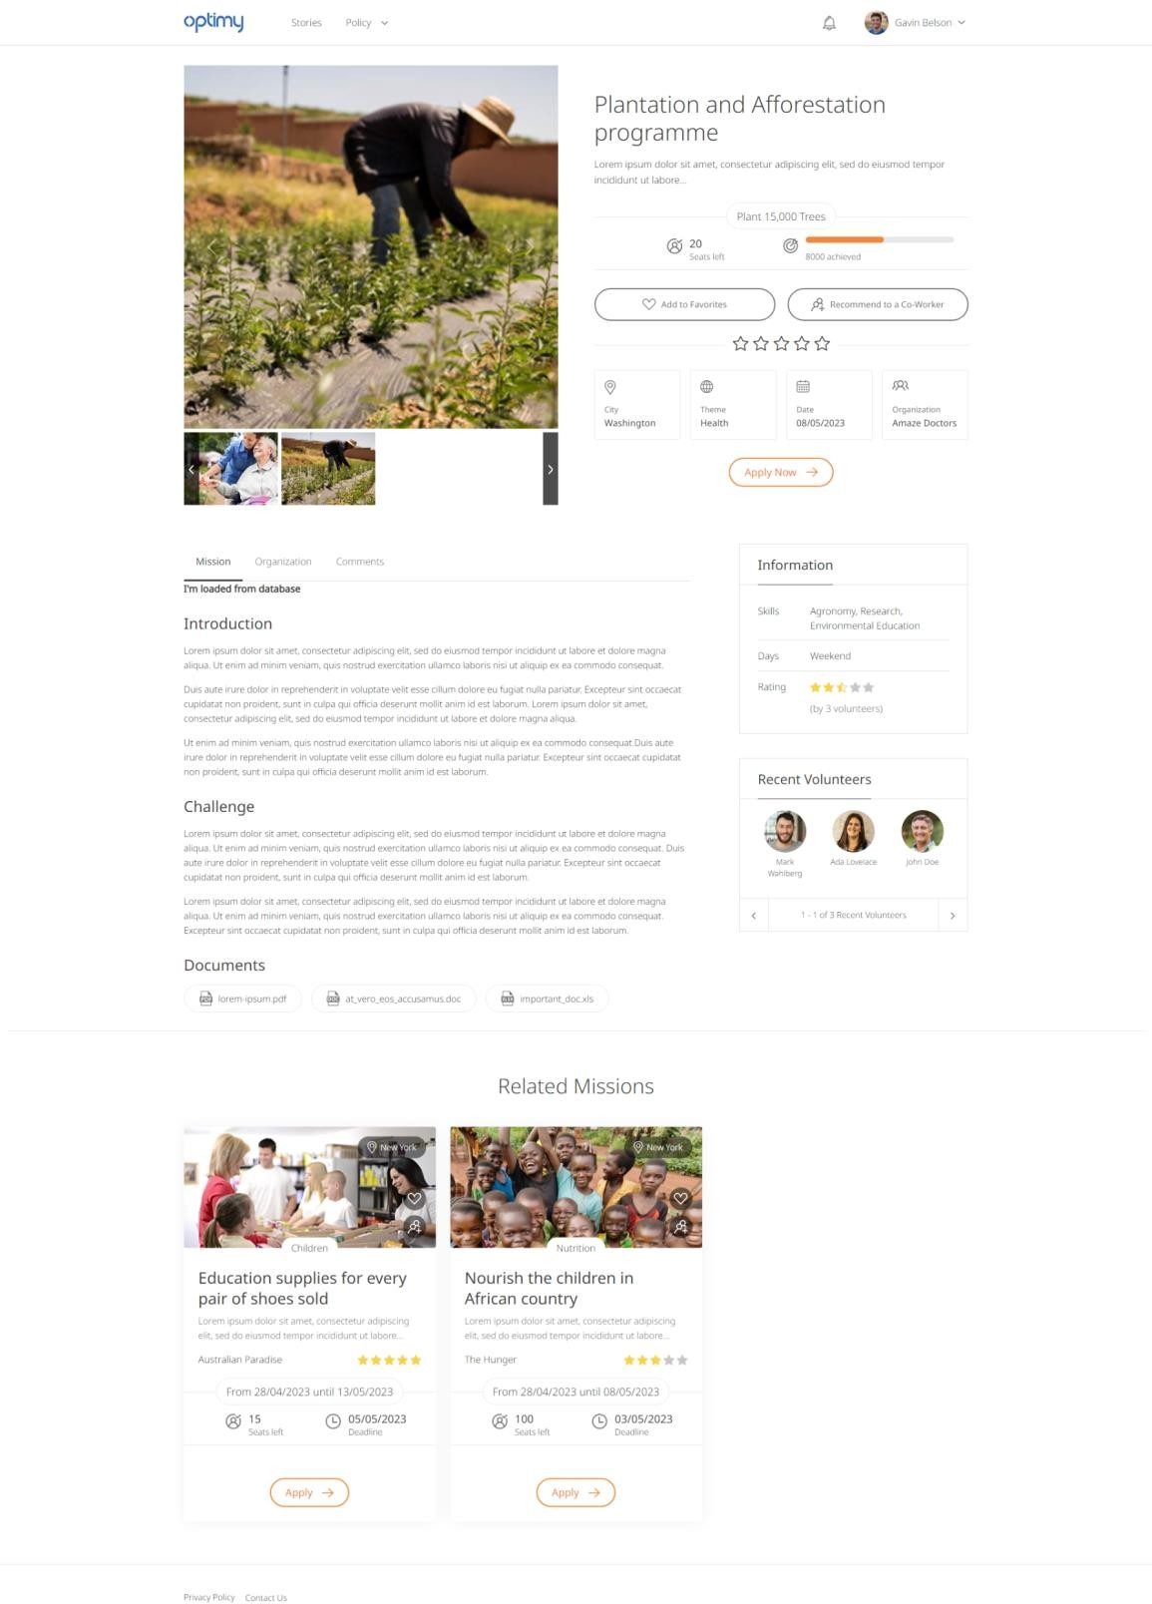

Fig.5.7VolunteeringMissionPage

## CHAPTER6.STORIES

Thisfeatureallowsuserstoviewandsubmitstoriesabouttheirexperience asvolunteers.

### STORYLISTING

Storylistingpageshows allthestoriespublished bytheuserswhohadpreviouslyappliedtoa mission.

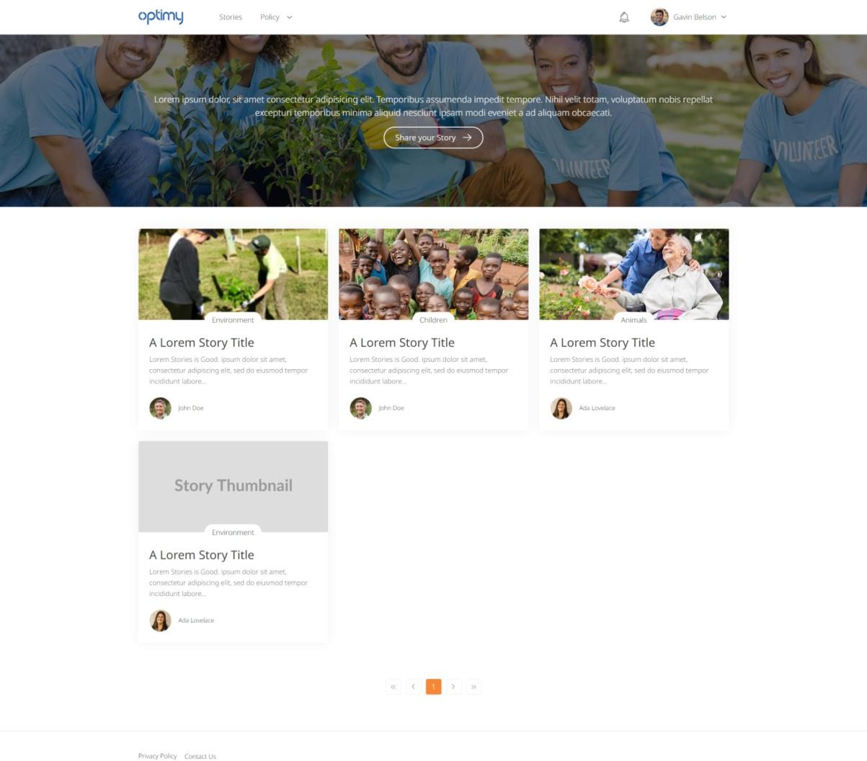

Fig.6.1StoryListingPage

### ADD/EDITSTORY

Usercansubmithisorherstoryfromthispage.Usermusthaveappliedtoamissionandmissionapplicationmustbeapprovedwhensubmittingastory.

Whenusersavesstorydetail,itwillbesavedasa**Draft**.Usercanthenpreviewhisstoryandwhen ready publishit.

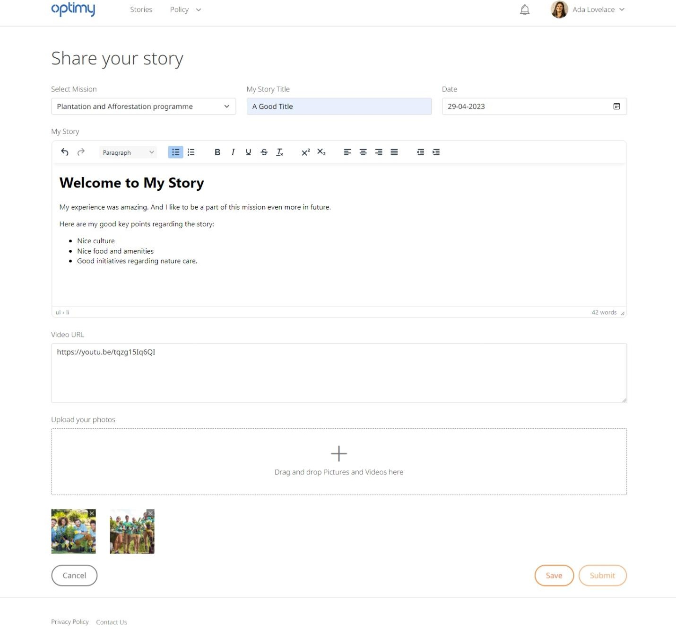

Fig.6.2Add/Edit aStory

### STORYDETAILS

Itwillshowdetailsofastory.Usercanviewstorytitle,description,media,anduserdetailsbywhomstoryisadded.User canalsorecommendastorytoaco-worker.

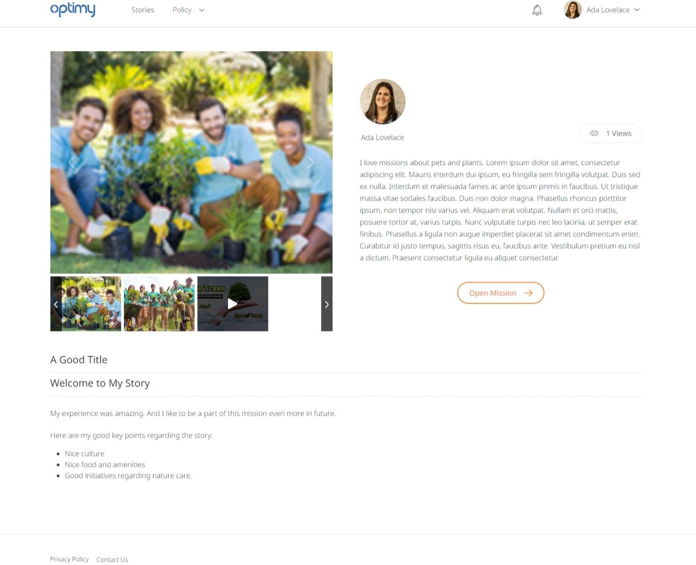

Fig.6.3StoryDetailsPage

## CHAPTER7.VOLUNTEERINGTIMESHEET

Inthissection,volunteerscanlogtheirworkforaparticularmissionbyfillingentriesin

**TimeandGoaltimesheets.**

### TIMEANDGOALTIMESHEETS

Thetimesheetsaredisplayedside-by-sideandallowtheuserstoaddanewentry,editanexistingentryand deleteanentry.

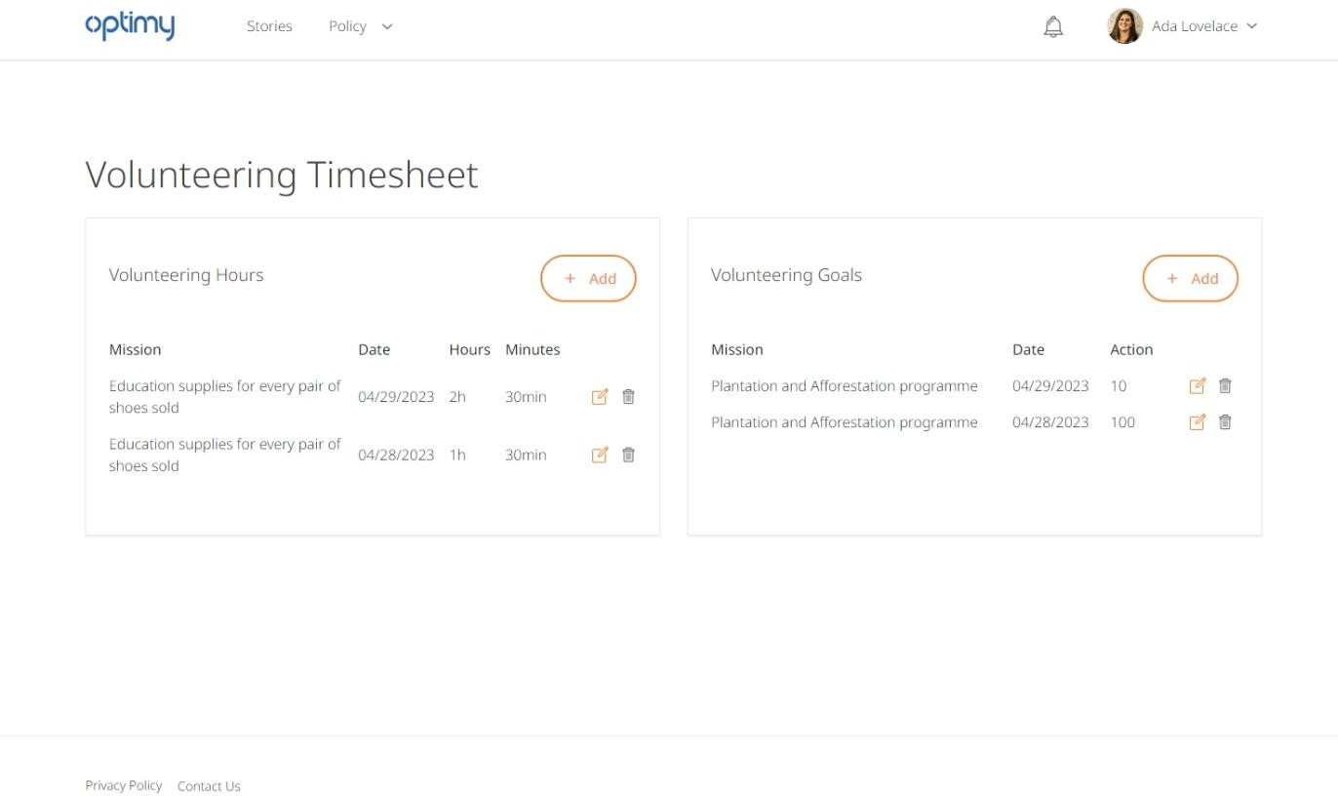

Fig.7.1Time&GoalTimesheets

### TIMEENTRY

Inatimeentry,usercanentertheamountofhoursandminuteshehadworkedandthevolunteeringdate.

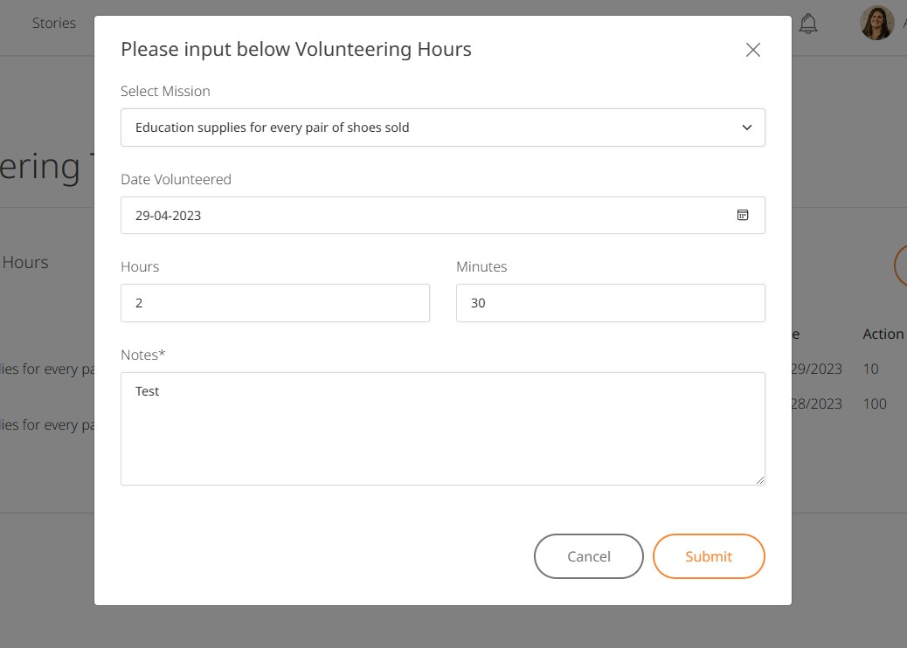

Fig.7.2Add/ EditTimeEntry

### GOALENTRY

Inagoalentry,theusercanentertheactionswhichisnothingbutanumberindicatinghowmuchprogresswasmadeto achievethefinal target.

Forexample,“Iplanted 100treesorIhelped2childrenwithfoodandstationary”.

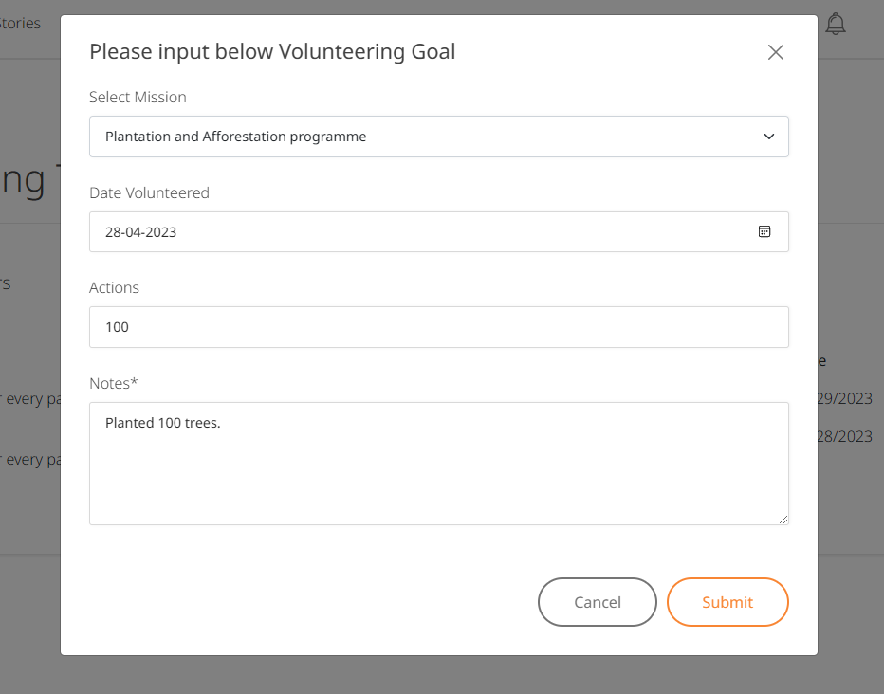

Fig.7.3Add/ Edit Goal Entry

## CHAPTER8.USERPROFILE

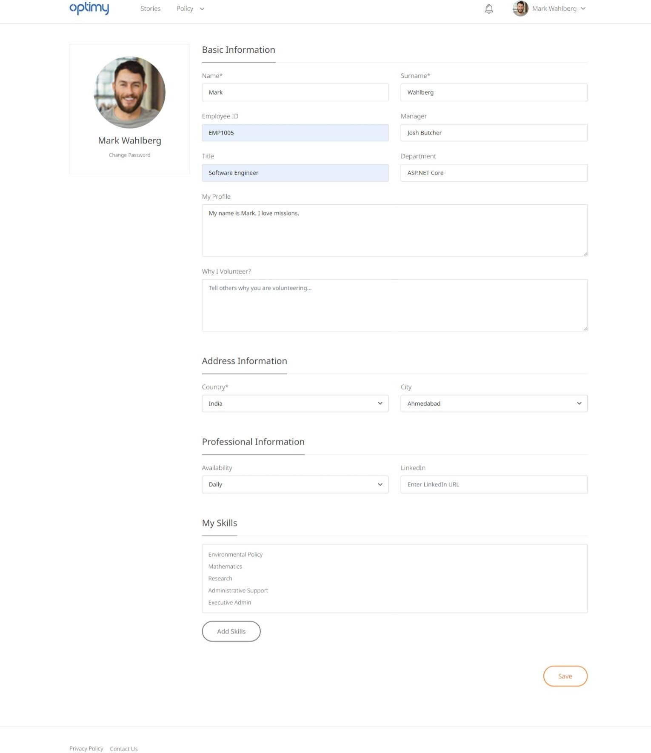

Fig.8.1MyProfile

Users can view their profile information and edit their basic details like name, email,changepassword andaddskills.

Belowfieldsaremandatory whenupdatinguserprofile:

* Name
* Lastname
* Country
* City

When user logs in and any of the above fields is empty, then his profile will be marked as“Incomplete” and hence will not be able to access any page of the platform. Once the userwillfill upthesemandatory fields,hewill beable to accessthewhole platform.

### CHANGEPASSWORD

Usercanchangehispasswordbyenteringtheold passwordandnewpassword.

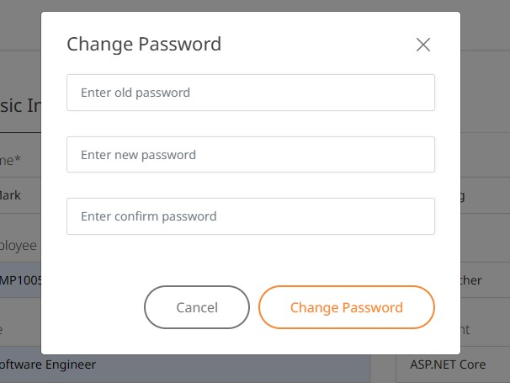

Fig.8.2ChangePassword

### USERSKILLS

Users can add or remove their skills through this popup. The skills are saved once the userSaveshisprofile.

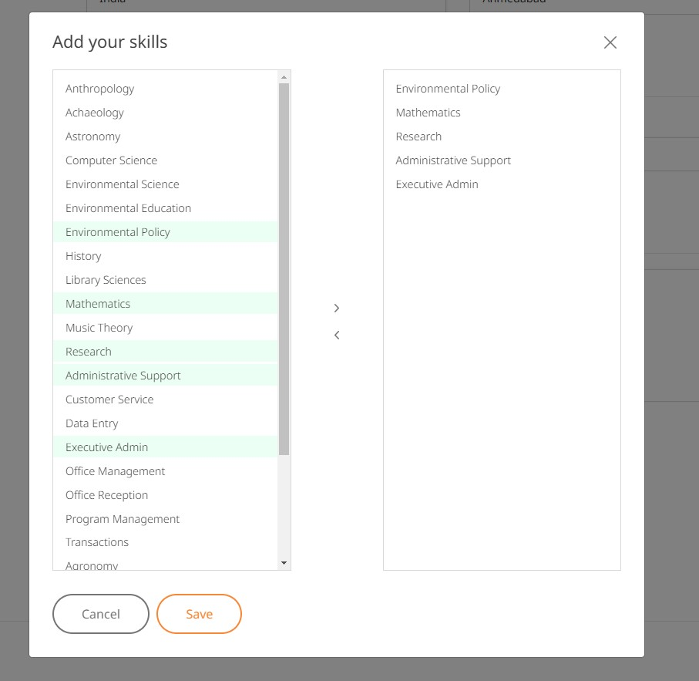

Fig.8.3UserSkills

### CONTACTUS

Ausercansendanybugs,opinion,suggestionorqueryregardingsystemdirectlyusingthispopup.Theuser needstopasshisemailin ordertoreceiveanyfutureresponses.

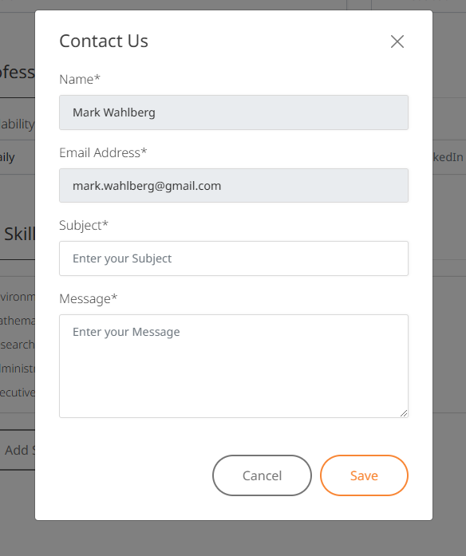

Fig.8.4Contact Us

## CHAPTER 9.ADMIN PANEL

An**AdminPanelis**providedforadministratorstomanagethedaterelatedtoCIPlatform.Theycan perform CRUDoperations onthefollowingentities:

* + - Users
    - CMSPage
    - Missions
    - MissionApplications
    - Themes
    - Skills
    - Stories
    - BannerManagement

The Admin has special privileges to access this panel apart from acting as a normal user.He can also preview a story submitted by the user for approval to**publish**or**reject**thestory.

TheAdmin canalsodisablesomespecificentitiesby changing their**Activestatus.**

### USERS

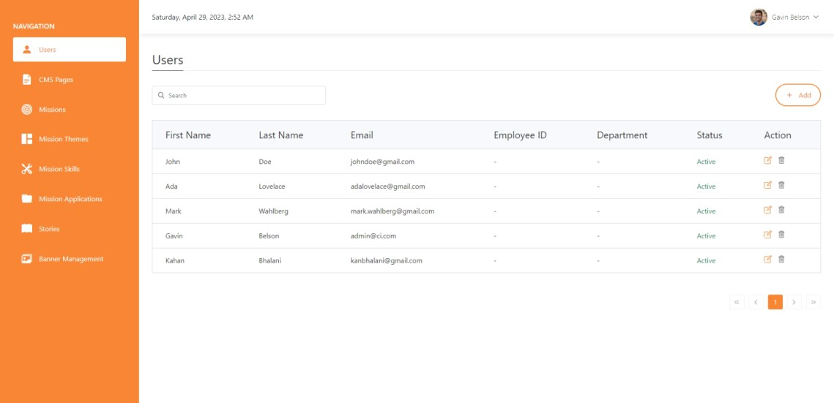

Fig.9.1UsersList

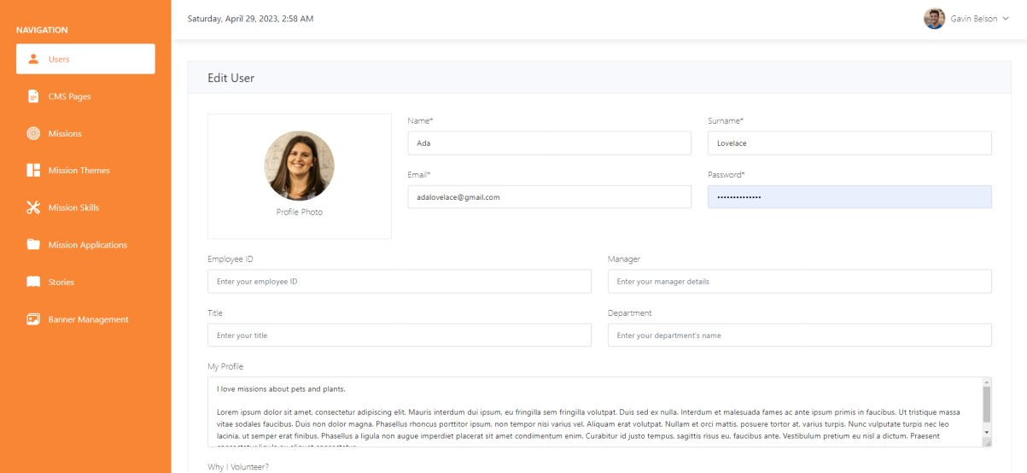

Fig.9.2Add/ EditUsers

### CMSPAGE

The Admin can add various CMS pages like Privacy Policy,Terms & Conditions, etc. Theaddedpageswill bevisible to everyoneviaauniquely identifying**slug**.

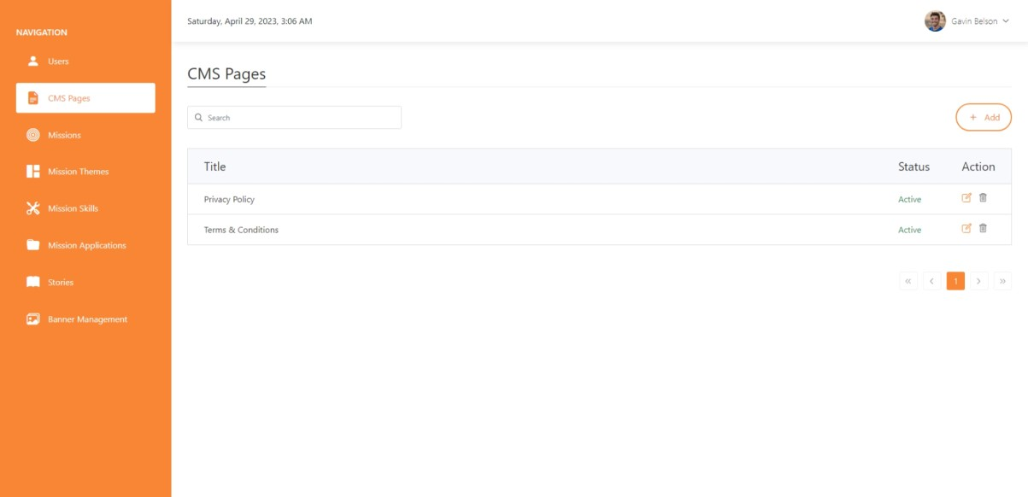

Fig.9.3CMSPagesList

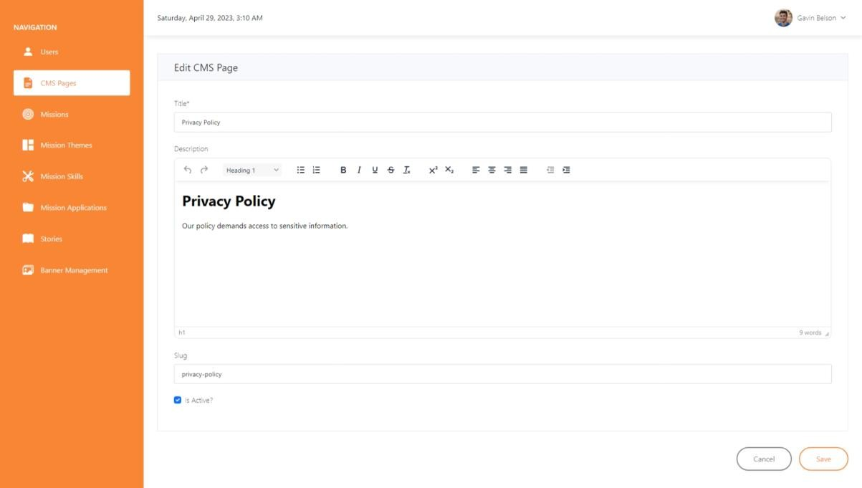

Fig.9.4Add/ EditCMSPage

### MISSIONS

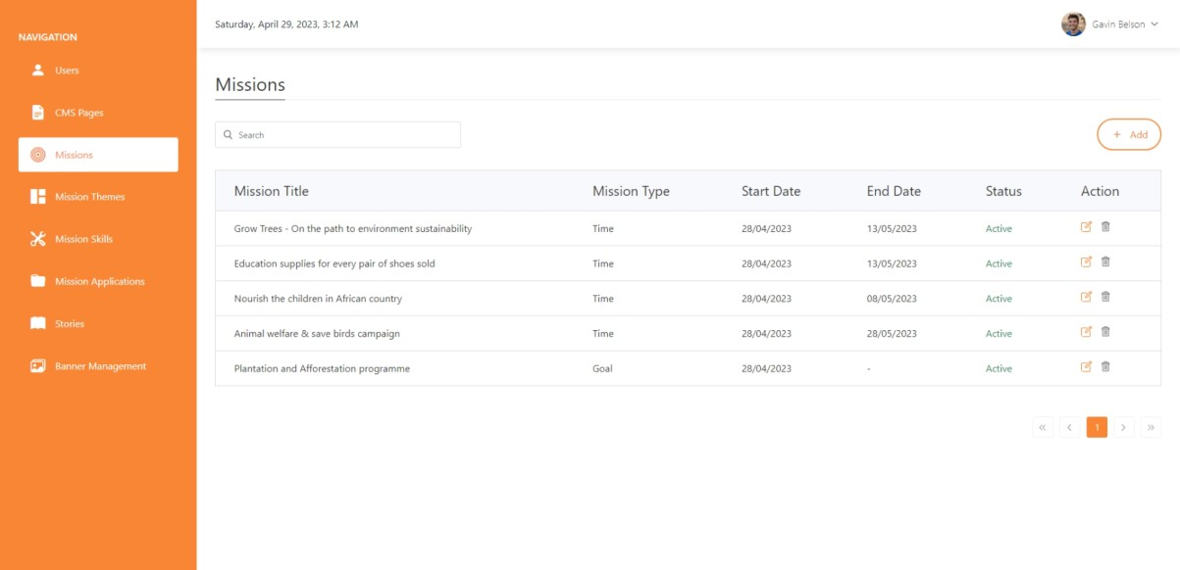

Fig.9.5MissionsList

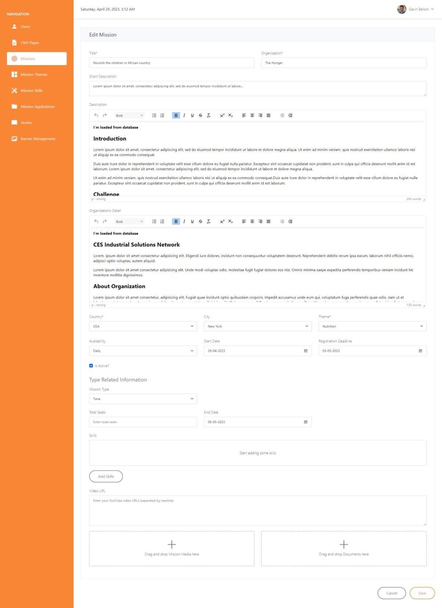

Fig.9.6Add/Edit Mission

### MISSIONSKILLS

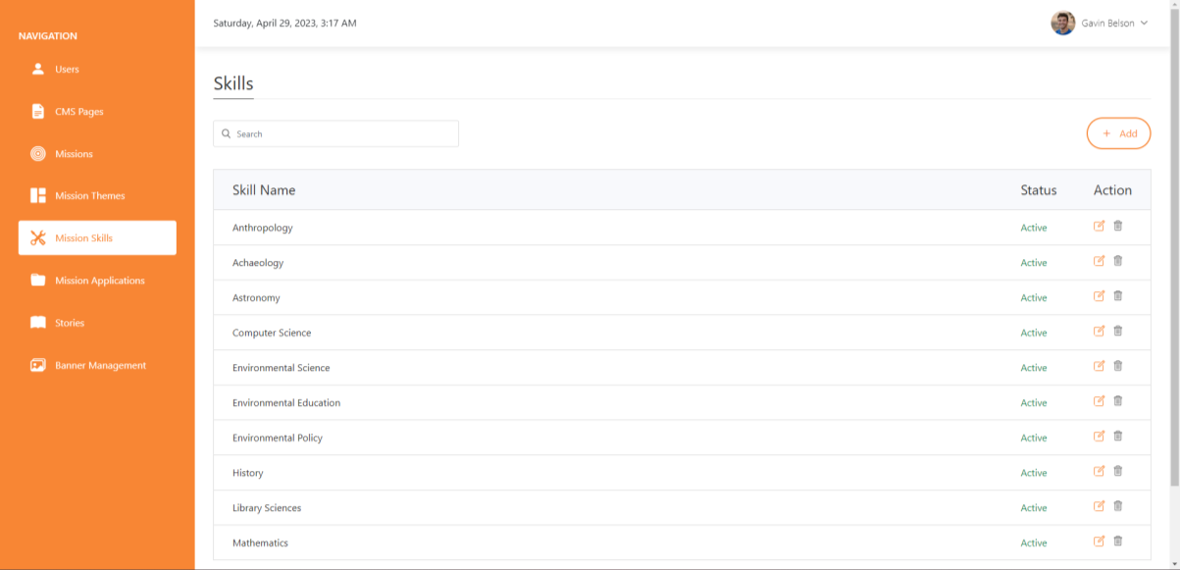

Fig.9.7SkillsList

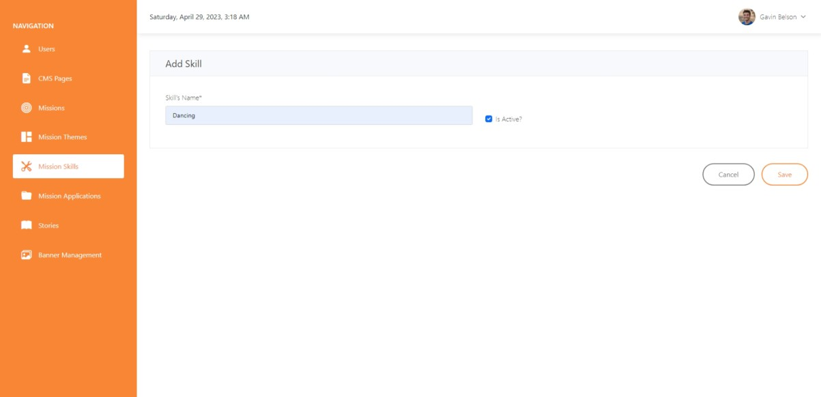

Fig.9.8Add/ Edit Skills

### MISSIONTHEMES

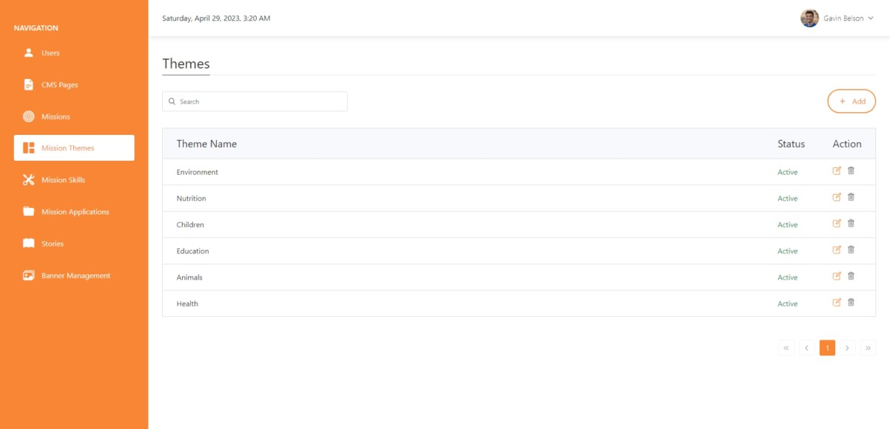

Fig.9.9ThemesList

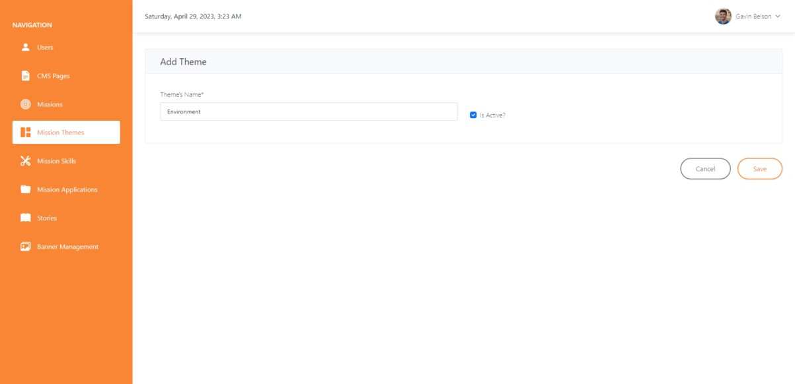

Fig.9.10Add/EditTheme

### MISSIONAPPLICATIONS

TheAdmincanviewallmissionapplicationsandhastherightstoeither**Approveor**

**Declinean**application.

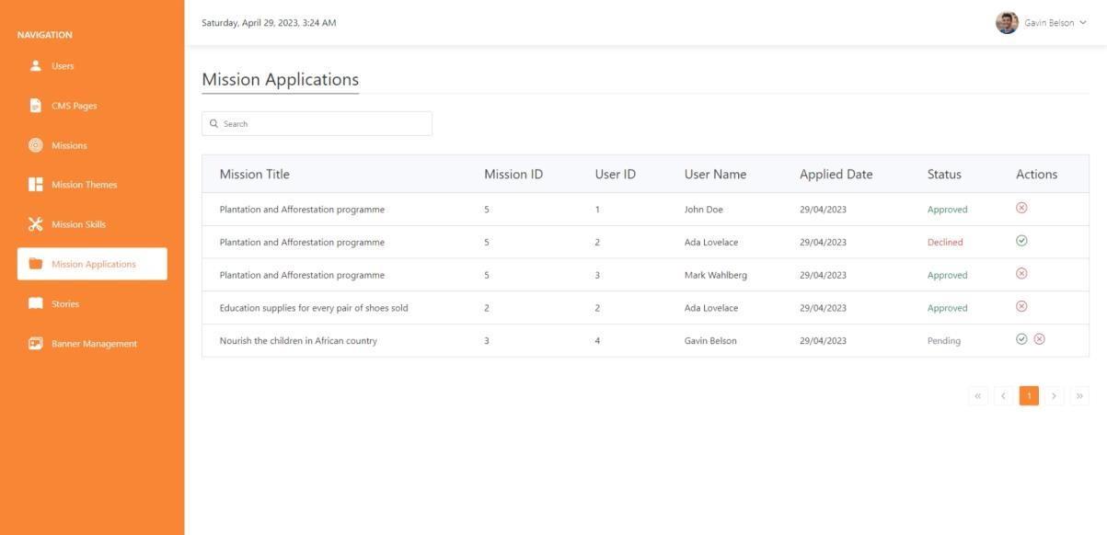

Fig.9.11MissionApplications

### STORIES

When a user publishesa story, it must be published by the Admin only. Unless the Adminpublishesthe story,it isnot publiclyvisibletoallvolunteers.

TheAdmincanalsoviewthestorypreviewpriortoapprovingitforpublication,aswellasdeletethe story.

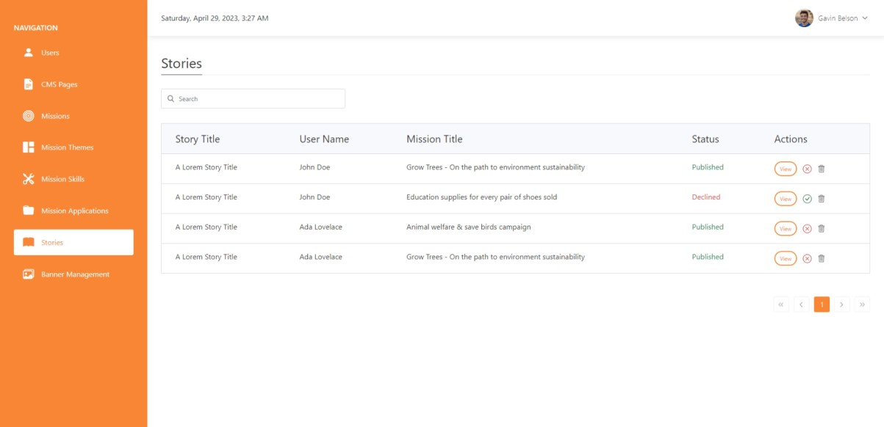

Fig.9.12PublishedStories

### BANNERMANAGEMENT

The banners displayed on all authentication pages are managed by the Admin through thisscreen.Hecanadd or delete newbannersandspecify thesortorder forthem.

ThebannerscarouselwillbedisplayedinthespecifiedsortorderbytheAdmin.

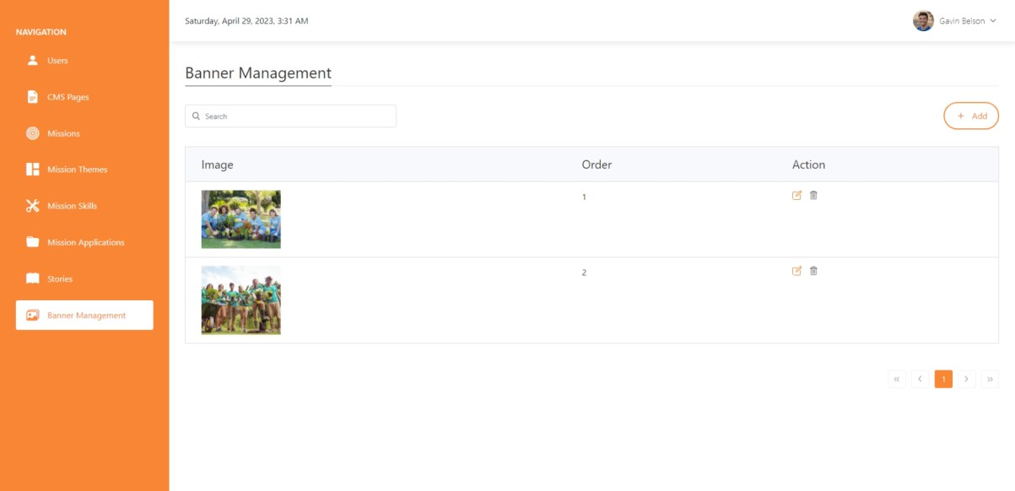

Fig.9.13BannersList

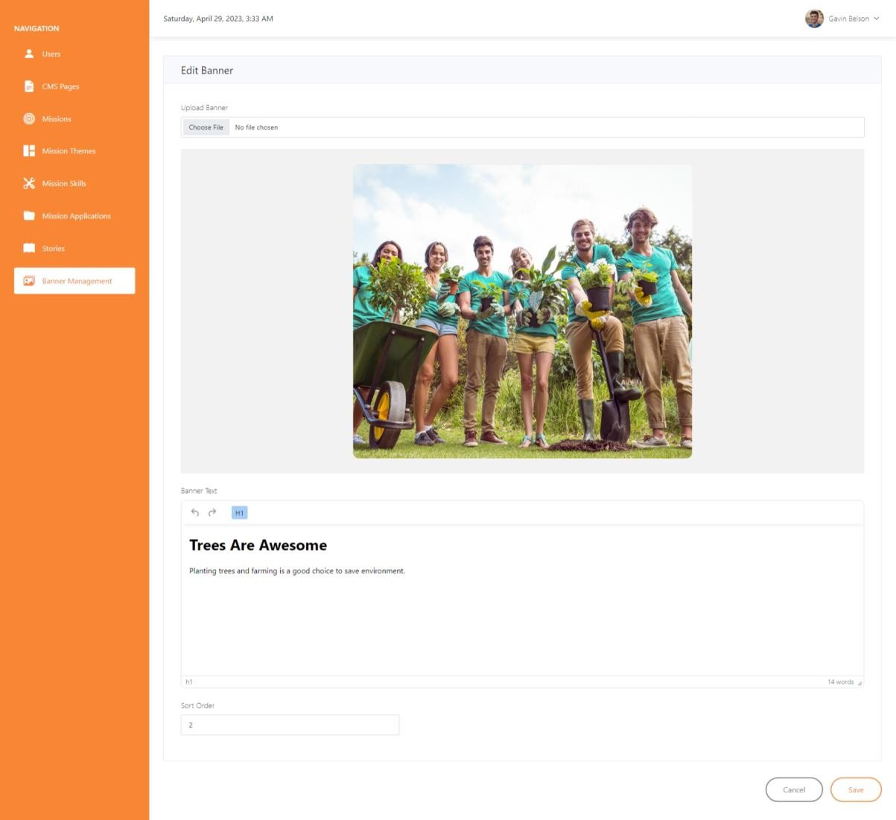

Fig.9.14Add /Edit Banner

## CHAPTER10.DIAGRAMS

### USECASEDIAGRAM

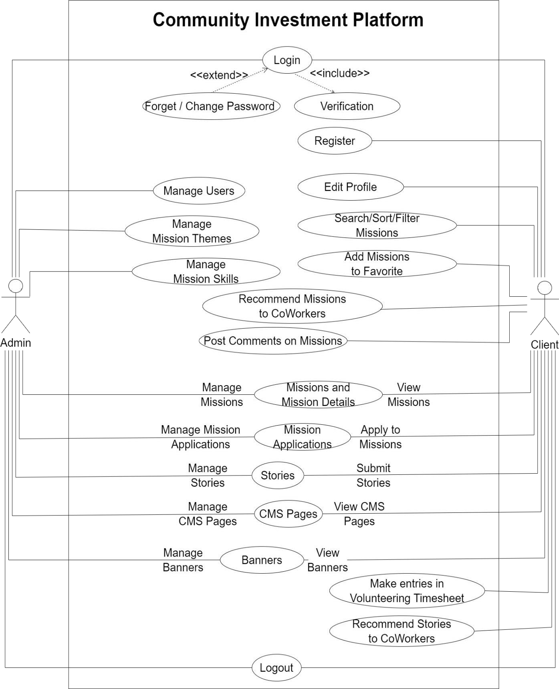

Fig.10.1UseCaseDiagram

### CLASSDIAGRAM

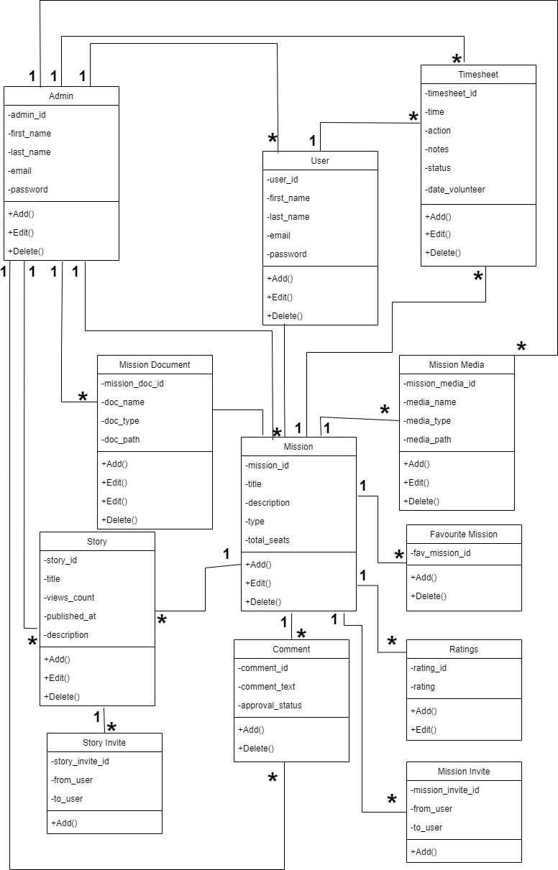

Fig.10.2Class Diagram

### SEQUENCEDIAGRAM

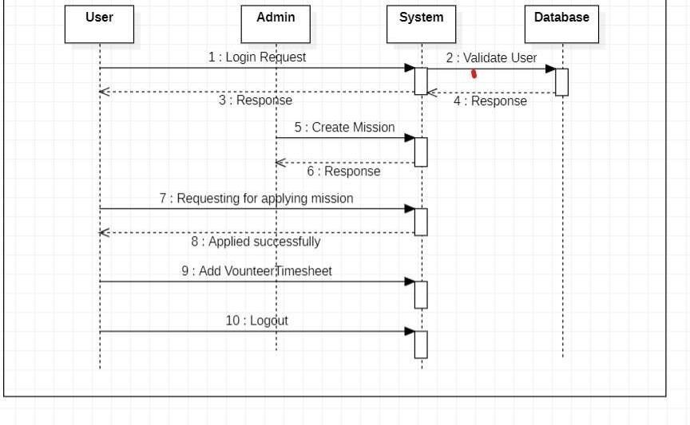

Fig.10.3SequenceDiagram

### E-RDIAGRAM

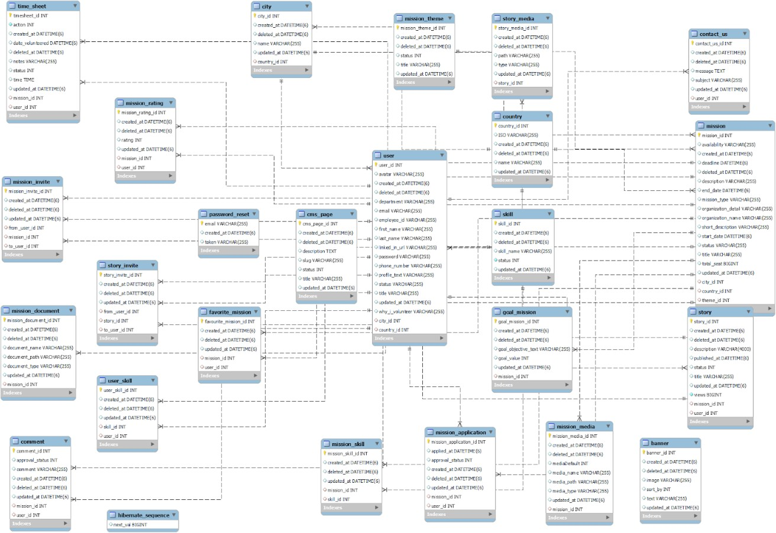

Fig.10.4E-RDiagram

### DATADICTIONARY

* + 1. **Banner**

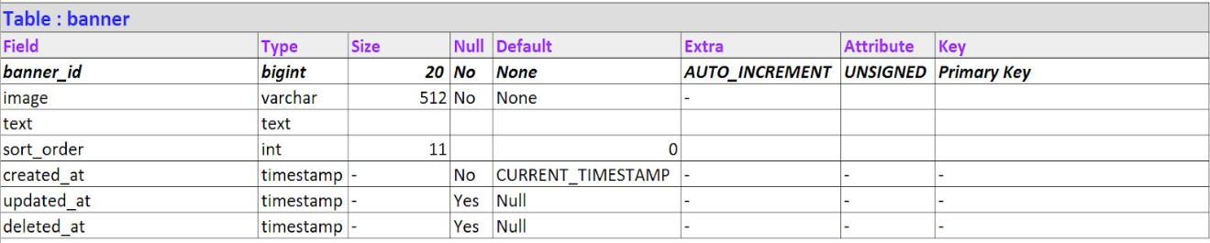

* + 1. **City**

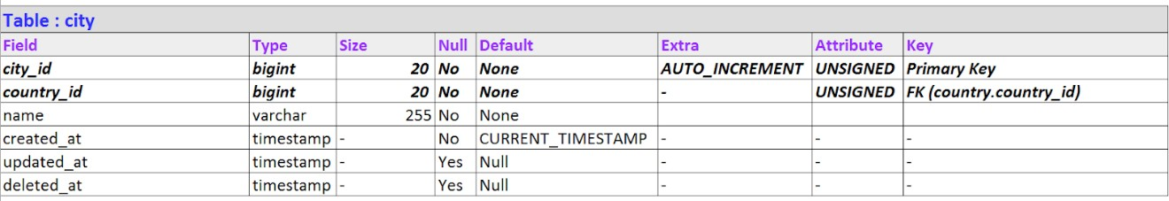

* + 1. **Comment**

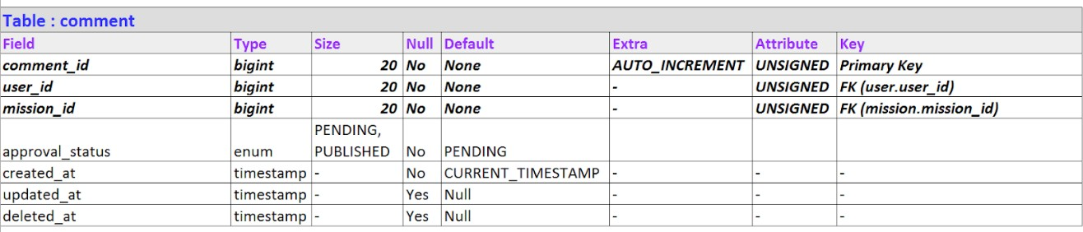

* + 1. **Country**

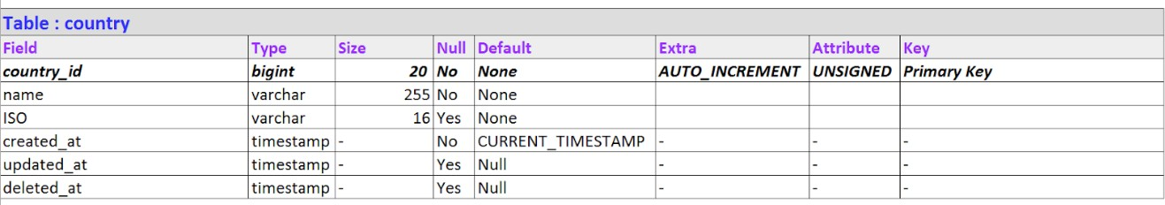

* + 1. **CMSPage**

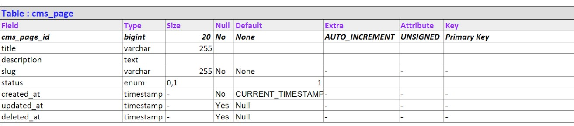

* + 1. **FavoriteMission**

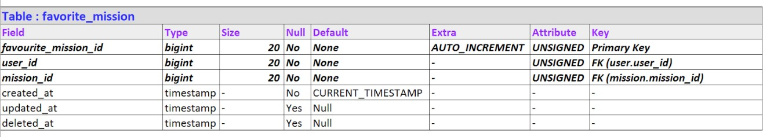

* + 1. **GoalMission**

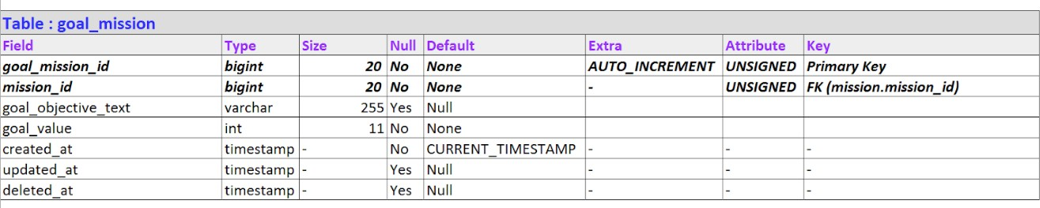

* + 1. **Mission**

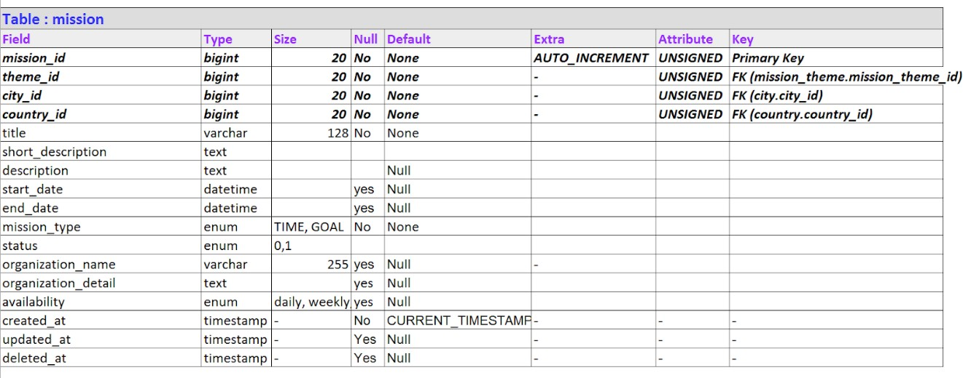

* + 1. **MissionApplication**

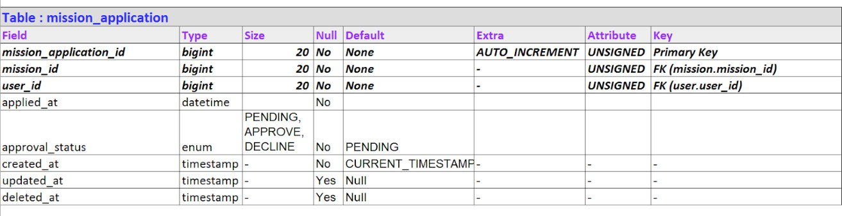

* + 1. **MissionDocuments**

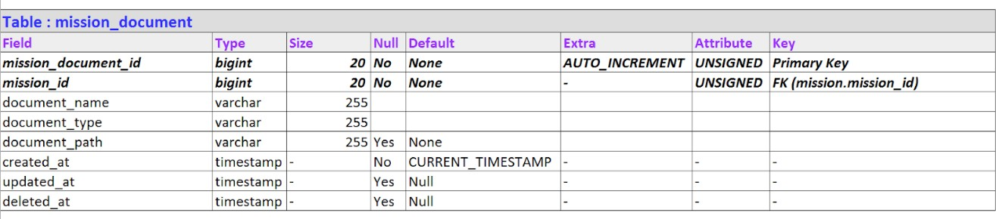

* + 1. **MissionInvite**

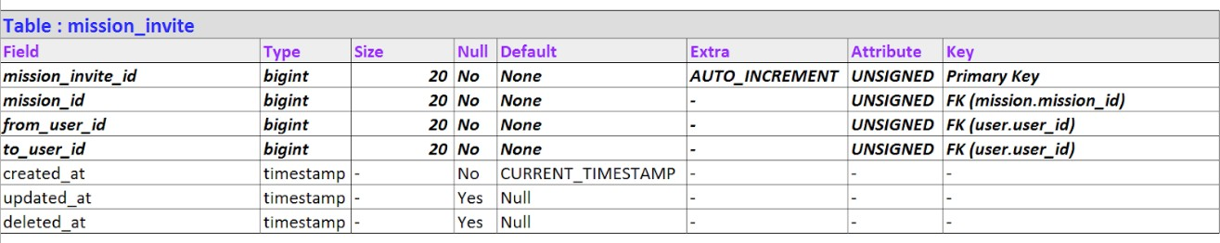

* + 1. **MissionMedia**

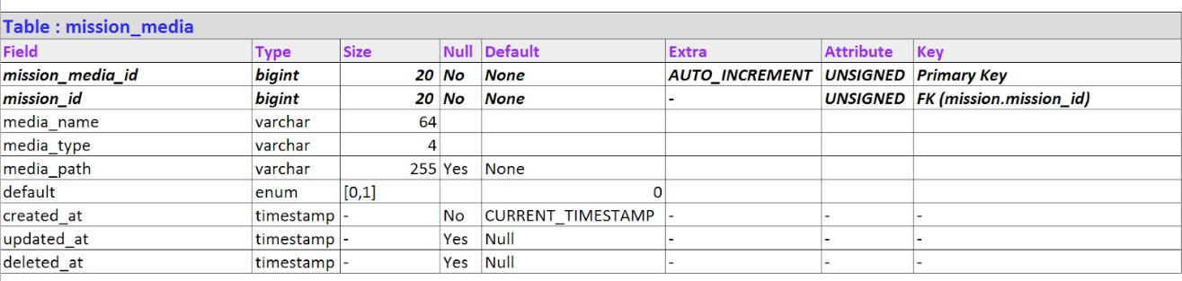

* + 1. **MissionRating**

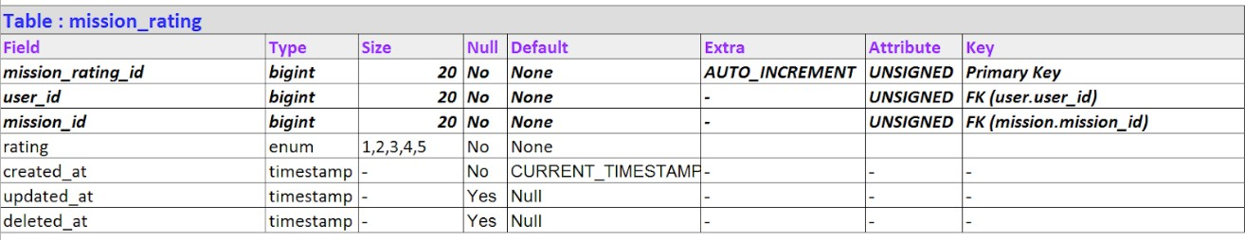

* + 1. **MissionSkill**

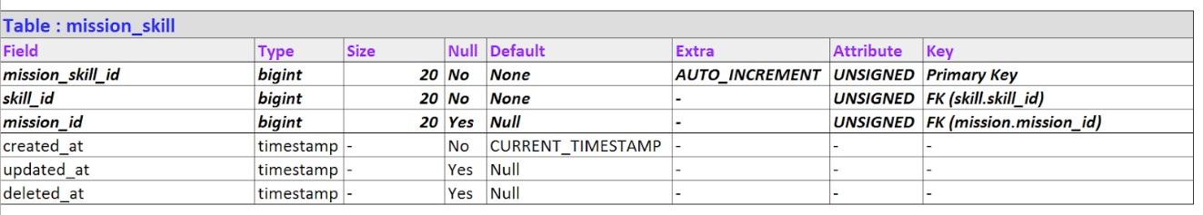

* + 1. 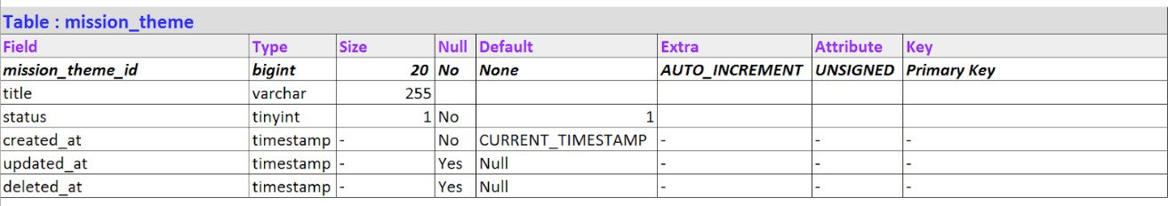**MissionTheme**
    2. 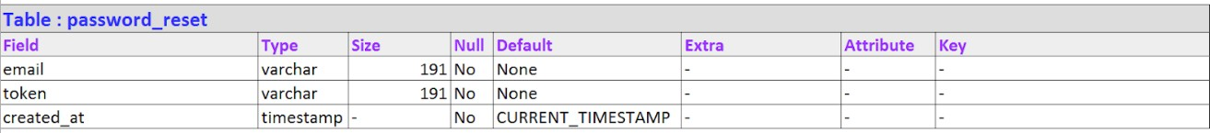**PasswordReset**
    3. 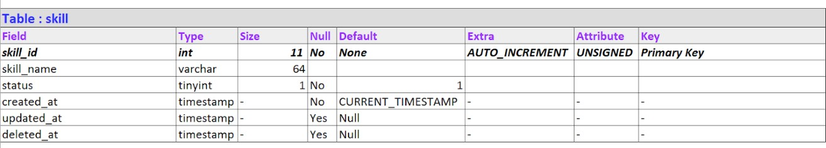**Skill**
    4. 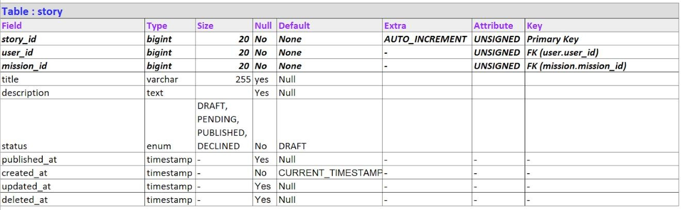**Story**
    5. **StoryInvite**

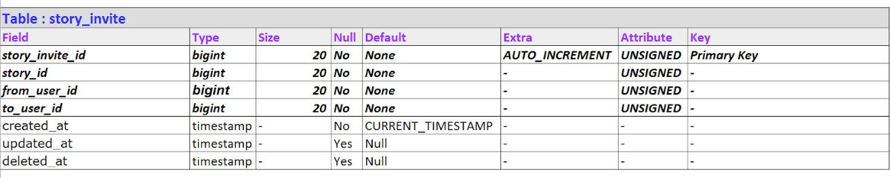

* + 1. **StoryMedia**

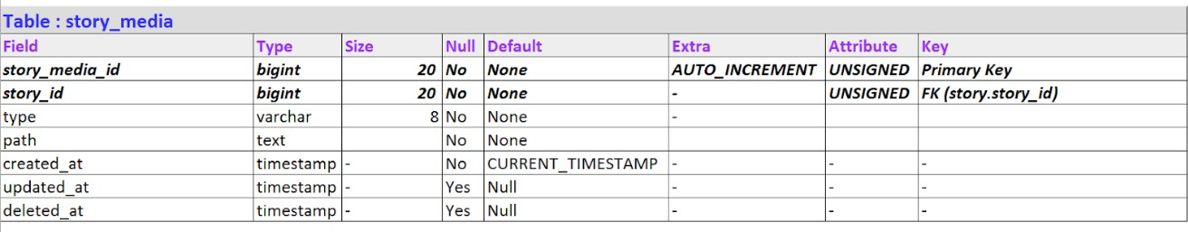

* + 1. **Timesheet**

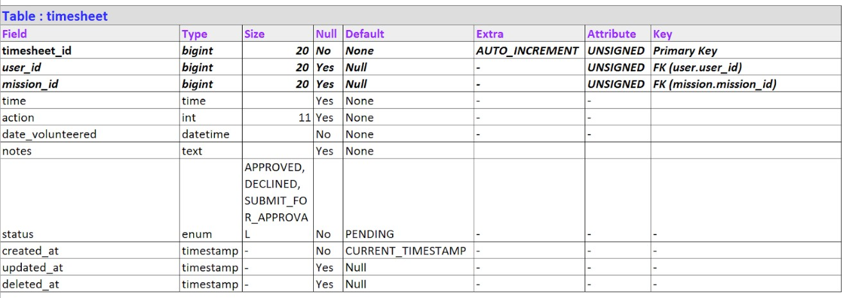

* + 1. **User**

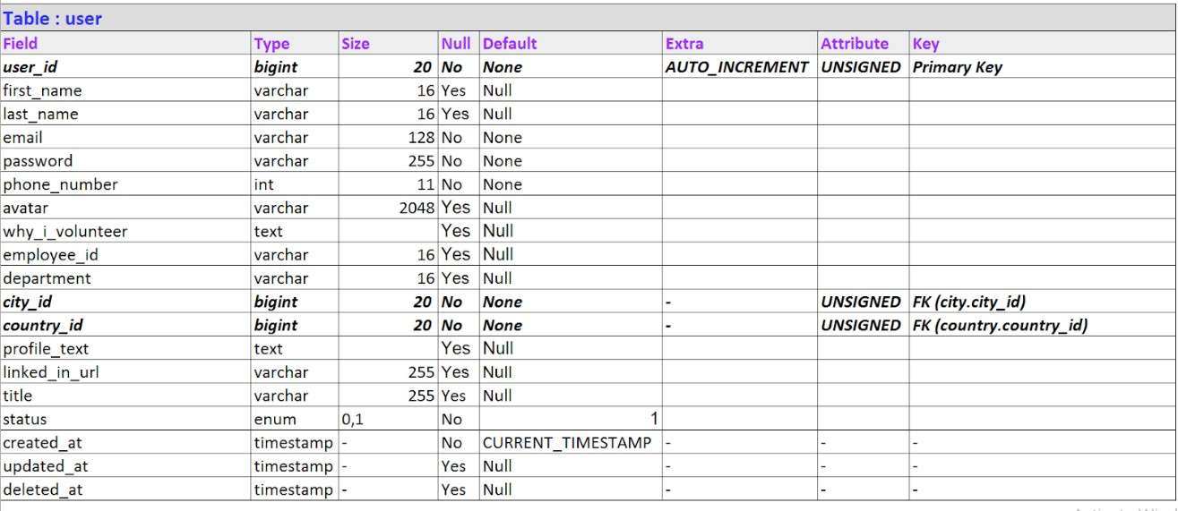

* + 1. **UserSkill**

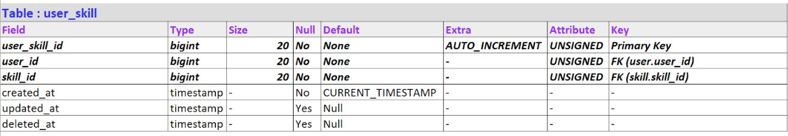

## CHAPTER11.CONCLUSION

We learnt many new concepts and technologies during our internship like ASP.NET CoreMVC,EntityFramework,BootstrapandSQLServer.Usingthesetechnologiescollectivelywewereabletodevelopanice-lookingwebapplication.Bydoingthisinternship,welearntwhat is the role of a Software Engineer in the industry and how to work on Frontend andtheBackend sideofwebdevelopment.

## REFERENCES

* + - * <https://www.tatvasoft.com/>
      * <https://dotnet.microsoft.com/en-us/apps/aspnet>
      * <https://getbootstrap.com/docs/5.1/getting-started/introduction/>
      * <https://docs.dropzone.dev/>
      * <https://learn.microsoft.com/en-us/ef/>